Contents
1.PROJECT SYNOPSIS----------------------------------------------------------5
1.1. Title of the Project-------------------------------------------------------------6
1.1.1. Introduction of the Project----------------------------------------------6
1.1.2. Objective of the Project-------------------------------------------------6
1.2. Scope of the project-----------------------------------------------------------6
1.2.1. Hardware Interfaces----------------------------------------------------7
1.2.2. Software Interfaces-----------------------------------------------------7
1.2.3. Programming Language-----------------------------------------------7
1.3. Project modules----------------------------------------------------------------8
1.4. Future scope of the project---------------------------------------------------8
2.SOFTWARE REQURIMENTS SPECIFICATION [SRS]--------------9

2.1. Introduction--------------------------------------------------------------------10

2.1.1. Purpose--------------------------------------------------------------------10

2.1.2. Intended Audience and Reading Suggestions------------------------11

2.1.3. Project Scope and Product Features-----------------------------------11

2.1.4. Definitions, acronyms, abbreviations----------------------------------11

2.1.5. References-----------------------------------------------------------------11
2.1.6. Overview-------------------------------------------------------------------12

2.2. Overall Description------------------------------------------------------------12

2.2.1. Product Perspective------------------------------------------------------12

2.2.2. Product Functions--------------------------------------------------------12

2.2.3. User Classes and Characteristics---------------------------------------12

2.2.4. Operating Environment--------------------------------------------------12

2.2.5. Design and Implementation Constraints--------------------------------13

2.2.6. User Documentation-------------------------------------------------------13

2.2.7. Assumptions and Dependencies-----------------------------------------13

2.3. Specific Requirements-----------------------------------------------------------13

2.3.1. External Interface Requirements----------------------------------------13

2.3.2. User interface--------------------------------------------------------------13

2.3.3. Hardware Interface--------------------------------------------------------13

2.3.4. Software interface---------------------------------------------------------14

2.3.5. Communication interface-------------------------------------------------14

2.4. Functional Requirements--------------------------------------------------------14

2.5. Other Nonfunctional Requirements--------------------------------------------15

2.5.1. Performance Requirements ----------------------------------------------15

2.5.2. Safety Requirements------------------------------------------------------15

2.5.3. Security Requirements----------------------------------------------------15

2.5.4. Software Quality Attributes----------------------------------------------15

3. SYSTEM DESIGN-------------------------------------------------------------17
3.1. Introduction-----------------------------------------------------------------------18
3.2. Applicable Documents----------------------------------------------------------18
3.3. Description of Programs--------------------------------------------------------19
3.3.1. Context Flow Diagram (CFD)----------------------------------------19
3.4. Data Flow Diagram--------------------------------------------------------------20
3.4.1. Notations in the DFD--------------------------------------------------21
3.5. Top Level DFD-----------------------------------------------------------------22
3.5.1.DFD Level 2.1-----------------------------------------------------------23
3.5.2.DFD Level 2.2-----------------------------------------------------------24
3.5.3.DFD Level 2.3-----------------------------------------------------------25
3.5.4.DFD Level 2.4-----------------------------------------------------------26
3.5.5.DFD Level 2.5-----------------------------------------------------------27
3.5.6.DFD Level 2.6---------------------------------------------------------28
3.5.7.DFD Level 2.7---------------------------------------------------------29
4.Data Base Design-------------------------------------------------------30
4.1. Introduction--------------------------------------------------------------------31

4.2. Database tables----------------------------------------------------------------31
4.3. Each entity can be described as follows along with its attributes-------32
4.4. Entity-Relationship Diagram------------------------------------------------36
4.5. The Symbols are shown in below table-------------------------------------36
4.6.ER-Diagram---------------------------------------------------------------------37
4.7. Schema Diagram---------------------------------------------------------------38
5.Detail Design-------------------------------------------------------------39
5.1. Introduction---------------------------------------------------------------------40
5.2. Applicable Documents--------------------------------------------------------40
5.3. Structure of the software package-------------------------------------------40
5.3.1. Administrator------------------------------------------------------------40
5.3.2. Employee-----------------------------------------------------------------40
5.3.3. User------------------------------------------------------------------------40
5.4. The project has following modules----------------------------------------------40
5.5. Modular Decomposition of Components---------------------------------------41
5.5.1. Admin Account Component---------------------------------------------41
5.5.2. RTO officer account Component----------------------------------------42
5.5.3. User Account Component------------------------------------------------42
5.5.4. Vehicle Registration Component----------------------------------------43
5.5.5. Online License Application Component--------------------------------43
5.5.6. Branch Component---------------------------------------------------------44
5.5.7. Report Component---------------------------------------------------------44
5.6. DETAIL DESIGN OF MODULES--------------------------------------------45
6.CODING-------------------------------------------------------------------59
6.1. Common Uses of PHP-----------------------------------------------------------60
6.2. Web server------------------------------------------------------------------------60
- Apache Web server------------------------------------------------------------60
- SQL SERVER------------------------------------------------------------------61
6.3. AJAX-----------------------------------------------------------------------------61
6.4. Source Code---------------------------------------------------------------------62
7.TESTING----------------------------------------------------------------101
7.1. Introduction---------------------------------------------------------------------102
7.2. Testing Objective--------------------------------------------------------------102
7.3. Testing Methods---------------------------------------------------------------103
7.4. Testing Steps-------------------------------------------------------------------103
7.5. Output Testing-----------------------------------------------------------------103
7.6. User Acceptance Testing----------------------------------------------------104
7.7.TEST CASES------------------------------------------------------------------104
7.7.1. Registration Form-----------------------------------------------------104
7.7.2. Login Form------------------------------------------------------------104
7.7.3. RTO Officials Page---------------------------------------------------105
7.7.4. Enroller Page----------------------------------------------------------105
7.7.5. User ONLINE LLR Apply------------------------------------------106
8.SCREENSHOTS-------------------------------------------------------107
9.USER MANUAL-------------------------------------------------------116
10.CONCLUSION-------------------------------------------------------119
11.BIBLIOGRAPHY----------------------------------------------------121
12. FUTURE ENHANCEMENT--------------------------------------123

CHAPTER-1
PROJECT SYNOPSIS

- PROJECT SYNOPSIS

1.1. Title of the Project:
RTO Management System
1.1.1. Introduction of the Project:
The Regional Transport Office (RTO) or Regional Transport Authority (RTA) is the organisation of the Indian government responsible for maintaining a database of drivers and a database of vehicles for various states of India. Currently RTO performing following activities:
- Registration of vehicles
- Motor vehicle tax collection
- Issue of licenses for public transit and freight traffic
- Conduct driving test and issue Learner's and Permanent driver's license and renewing the same
- Maintain database of registered vehicles
- Vehicle transfer and registration of mortgage transactions
- Maintaining a proper check on the validity of Insurance on motor vehicles
- Mechanical inspection of accidental vehicles
- Grant certificate of fitness to transport vehicles
- Issue badges to the drivers of public services vehicles like Auto rickshaws and Taxis
- Issue International driving permits

1.1.2. Objective of the Project:
The objective of RTO management system is to provide an online tool for the ease of RTO functions such as vehicle registration, Learner license, permanent license, renewal of license, and many more. This web application helps for RTO office employees as well as citizens of India. It will reduce considerably the difficulties faced on existing system, with minimum error and difficulties. The RTO employees having lot of work burden of making registration, License issue, transfer, etc., which required lot of paper work. Owning a motor vehicle is a dream for most people living in India. But the existing method cannot get the things done in right time, which waste the time, energy. “RTO Management System” has been designed to automate the process of registration of vehicle and issuing driving license process. System can make the daily activities efficient and providing the fast response to store and retrieve information.

1.2. Scope of the project:
The project has following features:
- This project works online which helps RTO office employees and Indian citizens.
- The System keeps track of the transactions in the RTO office.
- It maintains Renewal of Online LLR Form, Registration Form, Issue of permanent license, learner’s License, Renewal of permanent license, Issue of learner’s license, payment against challan and finally it produces printouts to payment of customers.
- This project prepared RTO office to maintain all the records like issuing the LL, DL, Vehicle registration, Vehicle ownership transfer etc. This will automate the process of registration of vehicle and issuing driving license process.
- System helps user to find their vehicle Information through online.
1.2.1. Hardware Interfaces:
- Operating System: UNIX, Linux, Mac, Windows etc.
- Processor: Pentium or Higher.
- RAM: 312MB or Higher.
- 14” monitor
- Keyboard and mouse
1.2.2. Software Interfaces:
- Development tool: PHP: Hypertext Pre-processor, JavaScript, Ajax
- Scripting server: Apache server
- Data Base server: MySQL
- IDE: Notepad++
1.2.3. Programming Language:
- Front End: PHP
- Back End: MySQL

1.3. Project Modules:
- Admin Account module: Administrator is the main user of the project. He has the power to verify the data entered by RTO officials.
- RTO officer account module: This module is for RTO officers to manage the user applications. Administrator is adding RTO official details. RTO officials do following task:
- Registration of vehicle
- Providing number for vehicle
- Issue of information's about driving licese.
- Renewal of license
- and many more
- User/Enroller account module: This module allows usert to register through online by entering profile details. After the succesfull registration the user can login to the system by entering login id and password.
  - User registration module
  - User login module
- Vehicle registration module: The module allows user to apply new registration of vehicles. Even this module allows to send vehicle transfer request.
  - Vehicle registration module
  - Vehicle transfer module

- Online License Application module: This module allows users to apply for Learner license, permanent license, changing the address of license, renew the license. RTO officials can verify and approve/reject received applications.
  - Learner license module
  - Permanent license module
  - Address modification module
  - License renewal module
- Branch module: This module allows user to add RTO branch details by entering branch name, branch description, etc.
- Report module: This module generates various kinds of reports.
  - Registration report
  - Vehicle registration report
  - Learner license report
  - Permanent license report
  - Address modification report
  - License renewal report
1.4. Future scope of the project:
- We can also add a provision to track a stolen vehicle in the future systems through GPS tracking.
- Fake registration plates, if any, would be detected immediately.
- We can implement this project in Android or iphone in future.

CHAPTER-2
SOFTWARE REQURIMENTS SPECIFICATION

2.Software Requirements Specification [SRS]

Introduction

This document is the Software Requirements Specifications for RTO Management System. The following document which provides the complete Software Requirements Specification (SRS) for “RTO Management System”.
The Regional Transport Office (RTO) or Regional Transport Authority (RTA) is the organization of the Indian government responsible for maintaining a database of drivers and a database of vehicles for various states of India. Currently RTO performing following activities:
- Registration of vehicles
- Motor vehicle tax collection
- Issue of licenses for public transit and freight traffic
- Conduct driving test and issue Learner's and Permanent driver's license and renewing the same
- Maintain database of registered vehicles
- Vehicle transfer and registration of mortgage transactions
- Maintaining a proper check on the validity of Insurance on motor vehicles
- Mechanical inspection of accidental vehicles
- Grant certificate of fitness to transport vehicles
- Issue badges to the drivers of public services vehicles like Auto rickshaws and Taxis
- Issue International driving permits

Purpose

The purpose of this document is to present a detailed description of the RTO Management System. It will explain the purpose and features of the system, the interfaces of the system, what the system will do, the constraints under which it must operate and how the system will react to external stimuli. This document is intended for both the stakeholders and the developers of the system.
The purpose of RTO management system is to provide a online tool for the ease of RTO functions such as vehicle registration, Learner license, permanent license, renewal of license, and many more. This web application helps for RTO office employees as well as citizens of India. It will reduce considerably the difficulties faced on existing system, with minimum error and difficulties. The RTO employees having lot of work burden of making registration, License issue, transfer, etc., which required lot of paper work. Owning a motor vehicle is a dream for most people living in India. But the existing method cannot get the things done in right time, which waste the time, energy. “RTO Management System” has been designed to automate the process of registration of vehicle and issuing driving license process. System can make the daily activities efficient and providing the fast response to store and retrieve information.

2.1.2. Intended Audience and Reading Suggestions
This document is for Administrator, Employees and Users of the web application. The document aims at explaining in an easy manner, the basic idea behind RTO Management System. Document helps developers and clients easy to understand. Future development objectives are also discussed in this document.

2.1.3. Project Scope and Product Features
The main scope of this project is:
- The system is convenient and flexible to be used. It saves their time, efforts, money and resources.
- User Friendliness is provided in the application with various controls provided by system Rich User Interface.
- The user information files can be stored in centralized database which can be maintained by the system.
- Online application feature is convenient and fast. With click of a mouse user can apply for LLR Form, license, learner’s License, Renewal of permanent license, Issue of learner’s license at any point of time.
- This project works online which helps RTO office employees and Indian citizens.
- The System keeps track of the transactions in the RTO office.
- It maintains Renewal of Online LLR Form, Registration Form, Issue of permanent license, learner’s License, Renewal of permanent license, Issue of learner’s license, payment against challan and finally it produces printouts to payment of customers.
- This project prepared RTO office to maintain all the records like issuing the LL, DL, Vehicle registration, Vehicle ownership transfer etc. This will automate the process of registration of vehicle and issuing driving license process.
- System helps user to find their vehicle Information through online.

2.1.4. Definitions, acronyms, abbreviations:
- SRS – Software requirements specifications.
- PHP - A server-side scripting language.
- MySQL - The database that will be used for this project.
- http – Hypertext transfer protocol
- www – World wide web
- RTO - Regional Transport Office

2.1.5. References
Books:
    - Software engineering by Pankaj Jalote.
    - Learning PHP, MySQL, JavaScript and CSS: A Step-by-Step Guide to Creating Dynamic Websites by Robin Nixon.
Website:
    - www.w3schools.com
    - www.tutorialspoint.com

2.1.6. Overview:
The remainder of this document includes three chapters and appendixes. The second one provides an overview of the system functionality and system interaction with other systems. This chapter also explains the system constraints and assumptions about the product. The third chapter provides the requirements specification in detailed terms and a description of the different system interfaces. Different specification techniques are used in order to specify the requirements more precisely for different audiences.

2.2. Overall Description
The following subsections provide complete overview of the SRS documentation for the product “RTO Management system”. For the rest of the document, we first define the overall product. Then, we give the external interface requirements, followed by a brief description of the product components and features. In the last section, we have provided the non-functional requirements of the product.

2.2.1. Product Perspective
With the ever-increasing popularity and accessibility of the internet, it is only natural that the educational community should want to make use of this tremendous resource. The administrative user interface concentrates on the consistent information that is practically, part of the organizational activities and which needs proper authentication for the data collection. The Interface helps the administration with all the transactional states like data insertion, data deletion, and data updating along with executive data search capabilities.
The operational and generic user interface helps the users upon the system in transactions through the existing data and required services. The operational user interface also helps the ordinary users in managing their own information helps the ordinary users in managing their own information in a customized manner as per the assisted flexibilities.

2.2.2. Product Functions
The product has following functions:
- The product works online with help of internet connection.
- The Email gateway integrated with this web application.
- This website is secured and each user needs to login the system to access account.

2.2.3. User/Enroller Classes and Characteristics
It is considered that the user does have the basic knowledge of operating the internet and to have access to it. The administrator is expected to be familiar with the interface of the tech support system.

2.2.4. Operating Environment
These are the major components to run this software. The server needs following tools to run the website:
- Apache Server
- MySQL Server

2.2.5. Design and Implementation Constraints
CO-1: The system’s design, code, and maintenance documentation shall conform to the Process Impact Intranet Development Standard, Version
CO-2: The system shall use the current corporate standard MySQL database engine.
CO-3: All HTML code shall conform to the HTML 4.0 standard.
CO-4: All scripts shall be written in PHP.

2.2.6. User/Enroller Documentation
UD-1: The system shall provide an online hierarchical and cross-linked help system in HTML that describes and illustrates all system functions.
UD-2: The online tutorial will be provided.

2.2.7. Assumptions and Dependencies
- Internet connection required.
- 24X7 uptime server connection required.
- One assumption about the product is that it will always be used on mobile phones that have enough performance.
- The user should have basic computer knowledge. They should be trained to handle the features provided by the system.
- The browser version should be used which have html5 support

2.3. Specific Requirements
This section contains all of the functional and quality requirements of the system. It gives a detailed description of the system and all its features.

2.3.1. External Interface Requirements:
This section provides a detailed description of all inputs into and outputs from the system. It also gives a description of the hardware, software and communication interfaces and provides basic prototypes of the user interface.

2.3.2. User/Enroller interface:
The major user classes that are expected to use this product are as follows:

Administrator: Administrator is a super user treated as owner of this site. He can have all the privileges. Administrator managing completed features of the website. Admin can approve driving license, vehicle registrations, etc. Administrator can add employees for each branch.

Employee: Employees are working for RTO Company who verifies user profile.

User: Users are citizens of India who can apply for LLR, permanent license, learner’s License, Renewal of permanent license, Issue of learner’s license

2.3.3. Hardware Interface:
- Operating system: Windows XP / Windows 7
- Hard disk: 40 GB hard disk
- RAM: 1 GB RAM
- Processor: Intel Pentium or above

2.3.4. Software interface:
- XAMPP 1.8.2
- Apache server
- PHP 5.4
- MYSQL server 5.5
- Notepad++

2.3.5. Communication interface:
The project shall use the HTTP protocol for communication over the internet and for the intranet communication will be through TCP/IP protocol suite.

2.4. Functional Requirements
The project has following modules:
- Admin Account module: Administrator is the main user of the project. He has the power to verify the data entered by RTO officials.
  - Add employees
  - View employees
  - Add branch
  - View branch
  - Verification of DL, LLR, Vehicle registration
- RTO officer account module: This module is for RTO officers to manage the user applications. Administrator is adding RTO official details. RTO officials do following task:
- Registration of vehicle
- Providing number for vehicle
- Issue of information's about driving license.
- Renewal of license
- and many more
- User/Enroller account module: This module allows user to register through online by entering profile details. After the successful registration the user can login to the system by entering login id and password.
  - User registration module
  - User login module
- Vehicle registration module: The module allows user to apply new registration of vehicles. Even this module allows to send vehicle transfer request.
  - Vehicle registration module
  - Vehicle transfer module
- Online License Application module: This module allows users to apply for Learner license, permanent license, changing the address of license, renew the license. RTO officials can verify and approve/reject received applications.
  - Learner license module
  - Permanent license module
  - Address modification module
  - License renewal module
- Branch module: This module allows user to add RTO branch details by entering branch name, branch description, etc.
  - Add branch
  - View branch
- Report module: This module generates various kinds of reports.
  - Registration report
  - Vehicle registration report
  - Learner license report
  - Permanent license report
  - Address modification report
  - License renewal report

2.5. Other Non-functional Requirements

2.5.1. Performance Requirements
This section lists the performance requirements expected from this Project:
- The users shall be able to add any records fewer than 5 seconds.
- The users shall be able to view any records fewer than 10 seconds.
- The users shall be able to download videos within 20 -40 seconds.
- The navigation between pages shall take fewer than 5 seconds.
- The application shall be able to do a validation check on the information provided in the user-authentication form and the place-order form to avoid false or incomplete information.

2.5.2. Safety Requirements
No safety requirements have been identified.

2.5.3. Security Requirements
- Users shall be required to log in to the System for all operations except viewing a item.
- The system shall permit only staff members who are on the list of authorized Menu Managers to create or edit items.

2.5.4. Software Quality Attributes
If the connection between the user and the system is broken prior to an order being either confirmed or canceled, the System shall enable the user to recover an incomplete order.
- RELIABILITY
It is tested for all the constraints at development stage

- AVAILABILITY
This system will only available till the system on which it is installed is running.

- SECURITY
This system is provided with authentication without which no user can pass. So only the legitimate users are allowed to use the application. If the legitimate users share the authentication information then the system is open to outsiders.

- MAINTAINABILITY
There will be no maintenance required for the website. The database is provided by the end-user and therefore is maintained by this user.

- PORTABILITY
The system works anywhere with the internet connection.

CHAPTER-3
SYSTEM DESIGN

3.System Design

3.1. INTRODUCTION
System design is a primary phase of the software development. System design aims to identify the modules that should be in the system. The specification of these modules and how they interact with each other are the desired results. The goal of the design process is to produce a module or representation of a system which can be used later to build that system. It is a plan for the solution of the system. Design includes requirement specification and final solution for satisfying the requirements. The system design attention is given to what components can be implemented in the software is considered.

This document is the design report for an online Regional Transport Office management System (RTOSYS). This is mainly about ‘how to do’ and will help provide an insight to the whole system design and implementation of the online Regional Transport Office system.
This software has the following three main components:
- Implementation of different type of users- Administrator, Users, RTO staff.
- Management of vehicle information along with the violations of the vehicle.
- Implement complaint option for users. The user can lodge a complaint on a particular accident or traffic violations.
- With the help of this website the registered user can use the services provided which include application for learner license, registration of vehicles, fee payment.

This project is aimed to developing an RTO system for the users. The entire project has been developed keeping in view of the distributed client-server computing technology, in mind. This project is to create an e-information about the services provided and computerize certain services.

3.2. APPLICABLE DOCUMENTS
The document used for preparing system design is Software Requirement Specification (SRS)

3.3. DESCRIPTION OF PROGRAMS

3.3.1. Context Flow Diagram (CFD)

A context Flow diagram (CFD) in software engineering and systems engineering is a diagram that defines the boundary between the systems, or part of a system, and its environment, showing the entities that interact with it. This diagram is a high-level view of a system. It is similar to a block diagram.

Fig.1: Context Flow Diagram of RTO System

3.4. Data Flow Diagram

A Data flow diagram is a graphical representation of the data flow of a particular information system. A data flow diagram can also be used for the visualization for the data processing. It is common practice for the designer to draw a context level DFD. It shows the interactive between the system and the outside entities. The context level DFD, is then exploded to show more detailed of the system being modelled
A DFD represents flow of data of a system. Data flow diagrams are commonly used during problem analysis. It views as a function that performs the input into the desired output. DFD shows movement of data through the different transformations or processes in the system.
Data flow diagrams are also known as bubble charts DFD is a designing tool used in the top-down approach to Systems Design. This context-level DFD is next expanded, to produce a Level 1 DFD that shows some of the detail of the system being modelled. The Level 1 DFD shows how the system is divided into sub-systems (processes), each of which deals with one or more of the data flows to or from an external agent, and which together provide all of the functionality of the system as a whole. It also identifies internal data stores that must be present in order for the system to do its job and shows the flow of data between the various parts of the system.

3.4.1. Notations in the DFD

Symbols | Description
  P  r  o  c  e  s  s | The circle or the bubble represents a process. A process is named and each process is represented by a name circle.
 | The source or sink is represented as a rectangular box. The source or sink is the net originator or the consumer of the data that flows in the system.
  Source/Sink
Database | The Database is represented with the open box symbol.
 | The arrow represents the flow of data in the system. The labelled arrow enters or leave the process or source/sink.

3.5. Top Level DFD (RTO System):

Fig.2: Top Level DFD Diagram of RTO System

3.5.1.DFD Level 2.1 (RTO System):
This level used to add RTO official record. First the admin needs to add all state records which stores in state table. Then admin needs to add city table which stores in city table. To add branch record admin needs to select state and city record. After adding branch record branch detail stores in branch table. While adding RTO officials the detail store in employee table. After adding RTO official data, the detail stores in employee table and RTO officials will receive and login credentials of the website.

Fig.3: DFD Level 2.1 Diagram of RTO System

3.5.2.DFD Level 2.2(RTO System):
This process explains how the vehicle type detail and vehicle registration detail stores in the database. Admin needs to add vehicle type and those detail stores in vehicletype table. From the customer end customer will apply for new vehicle registration. Entered vehicle detail stores in vehicleregistration table. After filling vehicle registration detail user needs to pay vehicle registration fee. Fee payment detail stores in payment table. Admin will check all the vehicle registration details and he verifies the detail for approval.

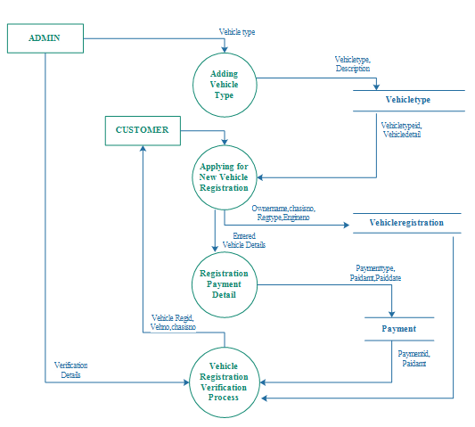
Fig.4: DFD Level 2.2 Diagram of RTO System

3.5.3.DFD Level 2.3(RTO System):
This module is registration module which helps to register to user through online. user needs to enter registration details by entering name, Email ID, password, contactno. Registration detail stores in user table. After the registration user can login to the website by entering emailid and password in the login process. The registration detail verifies from user table.

Fig.5: DFD Level 2.3 Diagram of RTO System

3.5.4.DFD Level 2.4(RTO System):
This process will explain how the Learning license application works in our project. First user needs to apply for learning license. After applying learning license those detail stores in llr table. After entering detail, the user needs to pay for learning license. From the employee end employee needs to take test to approve learning license. The test detail stores in test table. After the test the employee can verify or reject LLR application.

Fig.6: DFD Level 2.4 Diagram of RTO System

3.5.5.DFD Level 2.5(RTO System):
This process will explain how the Driving license feature works and how user can apply for driving license. First user needs to apply for Driving license and application detail stores in driving_license table. After entering detail, the user needs to pay for Driving license and payment detail stores in payment table. From the employee end employee needs to take test for driving license. The test detail stores in test table. After the test the employee can verify or reject Driving license application. Admin can issue or reject users driving license application.

Fig.7: DFD Level 2.5 Diagram of RTO System

3.5.6.DFD Level 2.6(RTO System):
This process will explain how to modify permanent address of driving license. First the user needs to enter existing driving license details. After entering existing driving license detail user can apply to modify the address. After applying modification request user needs to pay for it. From the employee end employee will verify and approve/reject the application. Admin will re issue modified driving license to the user.

Fig.8: DFD Level 2.6 Diagram of RTO System

3.5.7.DFD Level 2.7(RTO System):
This process explains how the license renewal application works online. User needs to apply to renew his existing driving license. After applying the renewal application stores in driving_license table. After applying the user needs pay renewal charge which stores in payment table. Admin will verify the license renewal application and he will verify/reject license renewal document.

Fig.9: DFD Level 2.7 Diagram of RTO System

CHAPTER - 4
Data Base Design

4.Data Base Design
4.1. Introduction:
- Database: A Database is collection of related data, which can be of any size and complexity. By using the concept of Database, we can easily store and retrieve the data. The major purpose of a database is to provide the information, which utilizes it with the information’s that the system needs according to its own requirements.

- Database Design: Database design is done before building it to meet needs of end-users within a given information-system that the database is intended to support. The database design defines the needed data and data structures that such a database comprises
- The database is physically implemented using MySQL.

4.2. The Database rto_management_system for is organized into 12 tables:

branch

city

drivinglicense

employee

payment

question

state

test

user

vehicle registration

vehicletype

4.3. Each entity can be described as follows along with its attributes

Table name: branch
Column | Data Type | Index | Description
Branched | int(10) | Primary key | Branch ID
Branchname | varchar(25) | Not null | Branch name
branchaddress | Text | Not null | Branch address
City | varchar(15) | Not null | City
Pin | varchar(10) | Not null | PIN code
State | varchar(25) | Not null | State
Status | varchar(10) | Not null | Branch status

Table name: city
Column | Data Type | Index | Description
Cityid | int(10) | Primary key | City ID
City | varchar(50) | Foreign key | City
Stated | int(10) | Foreign key | State ID
Citycode | varchar(10) | Not null | City Code
Description | Text | Not null | Discription
Status | varchar(10) | Not null | Status

Table name: employee
Column | Data Type | Index | Description
Empid | int(10) | Primary key | Emp ID
Emptype | varchar(20) | Not null | Emp Type
Branched | int(10) | Foreign key | Branch ID
Empname | varchar(25) | Not null | Emp Name
Loginid | varchar(100) | Not null | Login ID
Password | varchar(100) | Not null | Password
Status | varchar(10) | Not null | Status

Table name: payment
Column | Data Type | Index | Description
Paymentid | int(10) | Primary key | Payment ID
Paymenttype | varchar(25) | Not null | Payment Type
Paidfor | varchar(20) | Not null | Paid For
Paidamt | float(10,2) | Not null | Paid Amt
Paiddate | Date | Not null | Paid Date
Description | Text | Not null | Description
Status | varchar(10) | Not null | Status

Table name: drivinglicense
Column | Data Type | Index | Description
Drivinglicenseid | int(10) | Primary key | Driving License ID
Dltype | varchar(25) | Not null | DL Type
Stated | int(10) | Foreign key | State ID
Cityid | int(10) | Foreign key | City ID
Vehicletypeid | int(10) | Foreign key | VehicleType ID
Photo | varchar(100) | Not null | Photo
Name | varchar(50) | Not null | Name
Swdof | varchar(50) | Not null | SWD of
Paddr | Text | Not null | PAddress
Taddr | Text | Not null | TAddress
Paddrduration | varchar(50) | Not null | PAddr Duration
Dob | Date | Not null | DOB
Qualification | varchar(50) | Not null | Qualification
Identificationmarks | varchar(50) | Not null | Identification Marks
Bloodgroup | varchar(10) | Not null | Blood Group
Previousdl | varchar(50) | Not null | Previous DL
Startdate | date | Not null | Start Date
Enddate | date | Not null | End Date
Entrydate | date | Not null | Entry Date
Dlno | varchar(25) | Not null | DL No
Note | text | Not null | Note
Status | varchar(10) | Not null | Status

Table name: question
Column | Data Type | Index | Description
Qid | int(10) | Primary key | QID
Question | text | Not null | Question
option1 | text | Not null | Option 1
option2 | text | Not null | Option 2
option3 | text | Not null | Option 3
option4 | text | Not null | Option 4
Answer | varchar(25) | Not null | Answer
Img | text | Not null | Img
Status | varchar(10) | Not null | Status

Table name: llr
Column | Data Type | Index | Description
Llrid | int(10) | Primary key | LLR ID
Llrtype | varchar(50) | Not null | LLR Type
Stated | int(10) | Foreign key | State ID
Cityid | int(10) | Foreign key | City ID
Vehicletypeid | int(10) | Foreign key | Vehicle Type
Name | varchar(50) | Not null | Name
Swd | varchar(25) | Not null | SWD Of
Photo | varchar(100) | Not null | Photo
Paddr | text | Not null | PAddr
Taddr | text | Not null | Taddr
Paddrduration | varchar(50) | Not null | PAddr Duration
Dob | date | Not null | DOB
Birthplace | varchar(50) | Not null | Birth Place
Qualification | varchar(25) | Not null | Qualification
Identificationmarks | text | Not null | Identification Marks
Bloodgroup | varchar(25) | Not null | Blood Group
Startdate | date | Not null | Start Date
Enddate | date | Not null | End Date
Note | text | Not null | Note
Staus | varchar(10) | Not null | Status

Table name: state
Column | Data Type | Index | Description
Stated | int(10) | Primary key | State ID
State | varchar(50) | Not null | State
Statecode | varchar(10) | Not null | State Code
Description | text | Not null | Description
Status | varchar(10) | Not null | Status

Table name: test
Column | Data Type | Index | Description
Testid | int(10) | Primary key | Test ID
Userid | int(10) | Foreign key | User ID
Examfor | varchar(25) | Not null | Exam For
Qid | int(10) | Foreign key | Q ID
Answer | varchar(10) | Not null | Answer
Marks | int(10) | Not null | Marks
Status | varchar(10) | Not null | Status

Table name: user
Column | Data Type | Index | Description
Userid | int(10) | Primary key | User ID
Name | varchar(20) | Not null | Name
Emailed | varchar(25) | Not null | Email ID
Password | varchar(100) | Not null | Password
Contactno | varchar(15) | Not null | Contact No
Status | varchar(10) | Not null | Status

Table name: vehicleregistration
Column | Data Type | Index | Description
Vehicleregid | int(10) | Primary key | Vehicle Reg ID
Userid | int(10) | Foreign key | User ID
Stated | int(10) | Foreign key | State ID
Cityid | int(10) | Foreign key | City ID
Ownername | varchar(50) | Not null | Owner Name
Swdof | varchar(50) | Not null | SWD Of
Regtype | varchar(25) | Not null | Reg Type
Dob | date | Not null | DOB
Paddr | text | Not null | PAddr
Taddr | text | Not null | TAddr
Paddrduration | varchar(50) | Not null | PAddr Duration
Pancardno | varchar(25) | Not null | PanCard No
Birthplace | varchar(50) | Not null | Birth Place
Vehiclepurchasedfrom | text | Not null | Vehicle Purchased Form
Vehicletypeid | int(10) | Not null | Vehicle Type ID
Vehicledetail | text | Not null | Vehicle Detail
Chasisno | varchar(50) | Not null | Chasis No
Engineno | varchar(50) | Not null | Engine No
Seatingcapacity | varchar(50) | Not null | Seating Capacity
Fuel | varchar(50) | Not null | Fuel
Vehicleimg | varchar(100) | Not null | Vehicle Img
Note | text | Not null | Note
Date | date | Not null | Date
Vehicleno | varchar(50) | Not null | Vehicle No
Status | varchar(50) | Not null | Status

Table name: vehicletype
Column | Data Type | Index | Description
Vehicletypeid | int(10) | Primary key | Vehicle Type ID
Vehicletype | varchar(20) | Not null | Vehicle Type
Description | text | Not null | Description
Status | varchar(10) | Not null | Status

4.4. Entity-Relationship Diagram:
An entity-relationship (ER) diagram is a specialized graphic that illustrates the relationships between entities in a database. ER diagrams often use symbols to represent three different types of information. Boxes are commonly used to represent entities. Diamonds are normally used to represent relationships and ovals are used to represent attributes.
4.5. The Symbols are shown in below table:
Name | Notation | Description
Entity | 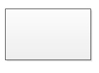 | Entity is represented by a box within the ERD. Entities are abstract concepts, each representing one or more instances of the concept in question. An entity might be considered a container that holds all of the instances of a particular thing in a system. Entities are equivalent to database tables in a relational database, with each row of the table representing an instance of that entity.
Relationship |  | Relationships are represented by Diamonds. A relationship is a named collection or association between entities or used to relate to two or more entities with some common attributes or meaningful interaction between the objects.
Attributes | 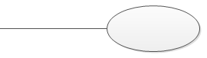 | Attributes are represented by Oval. An attribute is a single data item related to a database object. The database schema associates one or more attributes with each database entity.
4.6. ER- Diagram of RTO System:

4.7. Schema Diagram of RTO System:
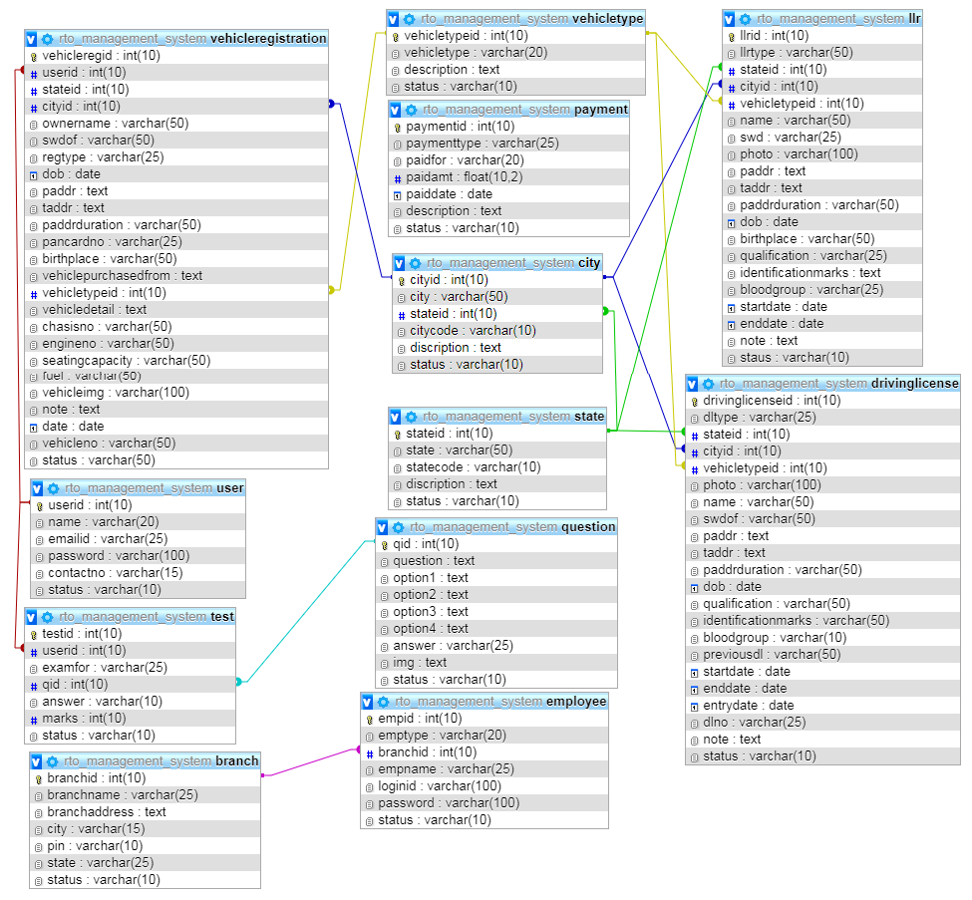

CHAPTER-5
Detail Design

5.Detail Design

5.1. Introduction:

The purpose of preparing this document is to explain complete design details of our RTO_Management_System.
This detailed design report will mainly contain the general definition and features of the project, design constraints, the overall system architecture and data architecture. Additionally, a brief explanation about our current progress and schedule of the project will be provided in related sections. Design of the system and subsystems/modules will be explained both verbally and visually by means of diagrams in order to help the programmer to understand all information stated in this document correctly and easily.

5.2. Applicable Documents:
The documents used during detailed design are
- System Requirements Document
- System Design
- Database Design

5.3. Structure of the software package:
The Components are –
5.3.1. Administrator:
- Administrator is a super user treated as owner of this site. He can have all the privileges.
- Administrator managing completed features of the website. Admin can approve driving license, vehicle registrations, etc. Administrator can add employees for each branch.
5.3.2. Employee:
- Employees are working for RTO Company who verifies user profile.
5.3.3. User:
- Users are citizens of India who can apply for LLR, permanent license, learner’s License, Renewal of permanent license, Issue of learner’s license
5.4. The project has following modules:
- Admin Account module: Administrator is the main user of the project. He has the power to verify the data entered by RTO officials.
- RTO officer account module: This module is for RTO officers to manage the user applications. Administrator is adding RTO official details.
- User account module: This module allows user to register through online by entering profile details. After the successful registration the user can login to the system by entering login id and password.
- Vehicle registration module: The module allows user to apply new registration of vehicles. Even this module allows to send vehicle transfer request.
- Online License Application module: This module allows users to apply for Learner license, permanent license, changing the address of license, renew the license. RTO officials can verify and approve/reject received applications.
- Branch module: This module allows user to add RTO branch details by entering branch name, branch description, etc.
- Report module: This module generates various kinds of reports.
5.5. Modular Decomposition of Components:
5.5.1. Admin Account Component:
- Identification of Modules:
The modules identified in this component are:
      - Add employees
      - View employees
      - Add branch
      - View branch
      - Verification of DL, LLR, Vehicle registration
- Structure chart for Admin Account:

5.5.2. RTO officer account Component:
- Identification of Modules:
The modules identified in this component are:
    - Registration of vehicle
    - Providing number for vehicle
    - Issue of information's about driving license.
    - Renewal of license
    - many more
- Structure chart for RTO officer account:

5.5.3. User Account Component:
- Identification of Modules:
The modules identified in this component are:
  - User registration module
  - User login module
- Structure chart for User Account:
5.5.4. Vehicle Registration Component:
- Identification of Modules:
The modules identified in this component are:
  - Vehicle registration module
  - Vehicle transfer module
- Structure chart for Vehicle Registration:

5.5.5. Online License Application Component:
- Identification of Modules:
The modules identified in this component are:
  - Learner license module
  - Permanent license module
  - Address modification module
  - License renewal module
- Structure chart for Online License Application:
5.5.6. Branch Component:
- Identification of Modules:
The modules identified in this component are:
  - Add branch
  - View branch
- Structure chart for Branch:
5.5.7. Report Component:
- Identification of Modules:
The modules identified in this component are:
      - Registration report
      - Vehicle registration report
      - Learner license report
      - Permanent license report
      - Address modification report
      - License renewal report
- Structure chart for Report:
5.6. DETAIL DESIGN OF MODULES

- RTO Officials
This level used to add RTO official record. First the admin needs to add all state records which stores in state table. Then admin needs to add city table which stores in city table. To add branch record admin needs to select state and city record. After adding branch record branch detail stores in branch table. While adding RTO officials the detail store in employee table. After adding RTO official data, the detail stores in employee table and RTO officials will receive and login credentials of the website.

Structured English

Flow chart to Adding RTO official record:
Name: Inserts state, city, branch, RTO officials.
Process description:
Input data flows: Adding state, branch, city, RTO official record
Output data flows:
- State inserted successfully
- Branch inserted successfully
- City record inserted successfully
- RTO official profile inserted successfully
For State:
If(state==valid)
Output: State list inserted successfully
Else
Output: Failed to insert state record...
End If
For City:
If(city==valid)
Output: city list inserted successfully
Else
Output: Failed to insert city record...
End If
For branch:
If(branch==valid)
Output: branch inserted successfully
Else
Output: Failed to insert branch record...
End If
For RTO officials:
if(RTO official == null)
Output: RTO official record inserted successfully..
Else
Output: to insert RTO official record..
End If

- Vehicle Registration
This process explains how the vehicle type detail and vehicle registration detail stores in the database. Admin needs to add vehicle type and those detail stores in vehicletype table. From the customer end customer will apply for new vehicle registration. Entered vehicle detail stores in vehicleregistration table. After filling vehicle registration detail user needs to pay vehicle registration fee. Fee payment detail stores in payment table. Admin will check all the vehicle registration details and he verifies the detail for approval.

Structured English
Flow chart for Vehicle registration:
Name: Adding vehicle type, Applying for New vehicle registration, Vehicle registration payment.
Process description:
Input data flows: Vehicle types, vehicle registration details, vehicle registration payment details
Output data flows:
- System inserts different types of vehicle types
- System inserts vehicle registration details
- System stores payment details
For Vehicle types:
If(vehicle types == added)
Output: Vehicle types inserted successfully
Else
Output: Failed to insert vehicle type
End If
For vehicle registration:
If(vehicle registration details== valid)
Output: Vehicle registration details inserted successfully
Else
Output: Failed to insert Vehicle registration details
End If
For payment record:
If(payment details == valid)
Output: Payment details added successfully
Else
Output: Failed to insert Payment record
End If

- User/Enroller Registration
This module is registration module which helps to register to user/enroller through online. user needs to enter registration details by entering name, Email ID, password, contactno. Registration detail stores in user table. After the registration user can login to the website by entering emailid and password in the login process. The registration detail verifies from user/enroller table.
Structured English
Flow chart for Enroller registration:
Name: To create enroller registration and login
Process description:
Input data flows: enroller registration detail, Enroller login detail
Output data flows:
- Enroller registration detail entered successfully
- Enroller logged in successfully
For enroller registration:
If(registrationdetails==valid)
emailid = Check whether entered email id is valid;
password = Check whether entered password is valid
ConfirmPassword = Check whether password and confirm password is valid
ContactNumber = Check whether contact number is valid
Output: Enroller registration done successfully
Else
Output: Failed to register
End If
For Enroller login:
if(Login credentials == valid)
Output: Logged in successfully..
Else
Output: Kindly enter valid login id and password
End If

- LLR Application
This process will explain how the Learning license application works in our project. First user needs to apply for learning license. After applying learning license those detail stores in llr table. After entering detail, the user needs to pay for learning license. From the employee end employee needs to take test to approve learning license. The test detail stores in test table. After the test the employee can verify or reject LLR application.

Structured English
Flow chart for Learning license registration:
Name: Applying for learning license, Making payment, Conducting test
Process description:
Input data flows: learning license details, Payment details, learning license verification details
Output data flows:
- System stores learning license details
- System stores payment details
- System verifies learning license record and issues learning license.
For Driving license:
If(learning license details== valid)
Output: learning license application entry done successfully
Else
Output: Failed to insert learning license application
End If
For payment record:
If(payment details == valid)
Output: Payment details added successfully
Else
Output: Failed to insert Payment record
End If
For test:
If(test == pass)
Output: learning license issued successfully
Else
Output: Failed to issue learning license
End If

- Driving License
This process will explain how the Driving license feature works and how user can apply for driving license. First user needs to apply for Driving license and application detail stores in driving_license table. After entering detail, the user needs to pay for Driving license and payment detail stores in payment table. From the employee end employee needs to take test for driving license. The test detail stores in test table. After the test the employee can verify or reject Driving license application. Admin can issue or reject users driving license application.

Structured English
Flow chart for Driving license registration:
Name: Applying for driving license, Making payment, Conducting test
Process description:
Input data flows: Driving license details, Payment details, Driving license verification details
Output data flows:
- System stores Driving license details
- System stores payment details
- System verifies driving license record and issues driving license.
For Driving license:
If(driving license details== valid)
Output: Driving license application entry done successfully
Else
Output: Failed to insert Driving license application
End If
For payment record:
If(payment details == valid)
Output: Payment details added successfully
Else
Output: Failed to insert Payment record
End If
For test:
If(test == pass)
Output: Driving license issued successfully
Else
Output: Failed to issue Driving license
End If
- Address Modification
This process will explain how to modify permanent address of driving license. First the user needs to enter existing driving license details. After entering existing driving license detail user can apply to modify the address. After applying modification request user needs to pay for it. From the employee end employee will verify and approve/reject the application. Admin will re issue modified driving license to the user.
Structured English
Flow chart for Address modification:
Name: Address modification
Process description:
Input data flows: New address
Output data flows: Address modified
For New address:
if(New address == valid)
Output: Address modified successfully..
Else
Output: Failed to modify address
End If
- License Renewal
This process explains how the license renewal application works online. User needs to apply to renew his existing driving license. After applying the renewal application stores in driving_license table. After applying the user needs pay renewal charge which stores in payment table. Admin will verify the license renewal application and he will verify/reject license renewal document.
Structured English
Flow chart for License renewal:
Name: Applying for license renewal, making payment
Process description:
Input data flows: License renewal detail, Renewal payment detail
Output data flows: System stores learning license application details and payment details.
For Learning license application record:
If(renewal entry == valid)
Output: Learning license record added successfully
Else
Output: Failed to insert Learning license record
End If
For payment record:
If(payment details == valid)
Output: Payment details added successfully
Else
Output: Failed to insert Payment record
End If

CHAPTER-6
CODING

6.CODING
PHP started out as a small open source project that evolved as more and more people found out how useful it was. Rasmus Lerdorf unleashed the first version of PHP way back in 1994. PHP is a recursive acronym for "PHP: Hypertext Pre-processor". PHP is a server-side scripting language that is embedded in HTML. It is used to manage dynamic content, databases, session tracking, even build entire e-commerce sites. It is integrated with a number of popular databases, including MySQL, PostgreSQL, Oracle, Sybase, Informix, and Microsoft SQL Server.
PHP is pleasingly zippy in its execution, especially when compiled as an Apache module on the Unix side. The MySQL server, once started, executes even very complex queries with huge result sets in record-setting time. PHP supports a large number of major protocols such as POP3, IMAP, and LDAP. PHP4 added support for Java and distributed object architectures (COM and CORBA), making n-tier development a possibility for the first time. PHP is forgiving: PHP language tries to be as forgiving as possible. It Syntax is C-Like.
6.1. Common Uses of PHP
The Uses of PHP are:
PHP can handle forms, i.e. gather data from files, save data to a file, through email you can send data, return data to the user. You add, delete, modify elements within your database through PHP. Access cookies variables and set cookies. Using PHP, you can restrict users to access some pages of your website. It can encrypt data.
6.2. Web server
A Web server is a server that is responsible for accepting HTTP requests from web clients and serving them HTTP responses, usually in the form of web pages containing static (text, images etc) and dynamic (scripts) content.
We have used 2 types of Web server:
- Apache Web server
- SQL SERVER

Apache Web server
The Apache Web server has been the most popular and widely used Web server for the last decade. It is used by approximately 50% of all websites. Apache is cross-platform, lightweight, robust, and used in small companies as well as large corporations. Apache is also free and open-source. This is a server has almost endless possibilities, due to its great modularity, which allows it to be integrated with numerous other applications. One of the most popular bundles is the LAMP Web server application stack, which includes the Apache Web server alongside MySQL, PHP, Perl, and Python. The Apache Web server is developed by the ApacheSoftwareFoundation.

SQL SERVER
Microsoft SQL Server is a relational database management system developed by Microsoft. As a database server, it is a software product with the primary function of storing and retrieving data as requested by other software applications—which may run either on the same computer or on another computer across a network (including the Internet).
Microsoft markets at least a dozen different editions of Microsoft SQL Server, aimed at different audiences and for workloads ranging from small single-machine applications to large Internet-facing applications with many concurrent users.

6.3. AJAX
Short for Asynchronous JavaScript and XML. It is a technique for creating fast and dynamic web pages. AJAX allows web pages to be updated asynchronously by exchanging small amounts of data with the server behind the scenes. This means that it is possible to update parts of a web page, without reloading the whole page.

AJAX is based on internet standards, and uses a combination of:
• XML Http Request object (to exchange data asynchronously with a server)
• JavaScript/DOM (to display/interact with the information)
• CSS (to style the data)
• XML (often used as the format for transferring data)
Examples of applications using AJAX: Google Maps, Gmail, YouTube, and Facebook tabs.

6.4. Source Code
- Dbconnection:

<?php
error_reporting(0);
$con=mysqli_connect("localhost","root","","rto_management_system");
// Check connection,
if (mysqli_connect_errno($con))
{
echo "Failed to connect to MySQL: " . mysqli_connect_error();
}
?>

- Header:

<?php
session_start();
error_reporting(0);
include("dbconnection.php");
$dt = date("Y-m-d");
//Enroller Profile starts here
if(isset($_SESSION[enrollerid]))
{
$sqlenrollerprofile ="SELECT * FROM enroller WHERE enrollerid='$_SESSION[enrollerid]'";
$qsqlenrollerprofile = mysqli_query($con,$sqlenrollerprofile);
$rsenrollerprofile = mysqli_fetch_array($qsqlenrollerprofile);
}
//Enroller Profile ends here
?>
<!DOCTYPE html>
<html lang="zxx">
<head>
<title>RTO Management System</title>
<!--meta tags -->
<meta charset="UTF-8">
<meta name="viewport" content="width=device-width, initial-scale=1">
<meta name="keywords" content="RTO Management System" />
<script>
addEventListener("load", function () {
setTimeout(hideURLbar, 0);
}, false);

function hideURLbar() {
window.scrollTo(0, 1);
}
</script>
<!--//meta tags ends here-->
<!--booststrap-->
<link href="css/bootstrap.min.css" rel="stylesheet" type="text/css" media="all">
<!--//booststrap end-->
<!-- font-awesome icons -->
<link href="css/fontawesome-all.min.css" rel="stylesheet" type="text/css" media="all">
<!-- //font-awesome icons -->
<link href="css/blast.min.css" rel="stylesheet" />
<link rel="stylesheet" type="text/css" href="css/style10.css" />
<!--stylesheets-->
<link href="css/style.css" rel='stylesheet' type='text/css' media="all">
<link href="css/validationcss.css" rel='stylesheet' type='text/css' media="all">
<!--//stylesheets-->
<link href="//fonts.googleapis.com/css?family=Montserrat:300,400,500" rel="stylesheet">
<link href="//fonts.googleapis.com/css?family=Merriweather:300,400,700,900" rel="stylesheet">
<link href="css/jquery.dataTables.min.css" rel='stylesheet' type='text/css' media="all">
</head>
<body>

<style>
#mmenu, #mmenu ul {
margin: 0;
padding: 0;
list-style: none;
}
#mmenu {
width: 100%;

border: 1px solid #222;
background-color: #111;
background-image: -moz-linear-gradient(#444, #111);
background-image: -webkit-gradient(linear, left top, left bottom, from(#444), to(#111));
background-image: -webkit-linear-gradient(#444, #111);
background-image: -o-linear-gradient(#444, #111);
background-image: -ms-linear-gradient(#444, #111);
background-image: linear-gradient(#444, #111);
-moz-border-radius: 6px;
-webkit-border-radius: 6px;
border-radius: 6px;
-moz-box-shadow: 0 1px 1px #777, 0 1px 0 #666 inset;
-webkit-box-shadow: 0 1px 1px #777, 0 1px 0 #666 inset;
box-shadow: 0 1px 1px #777, 0 1px 0 #666 inset;
}
#mmenu:before,
#mmenu:after {
content: "";
display: table;
}
#mmenu:after {
clear: both;
}
#mmenu {
zoom:1;
}
#mmenu li {
float: left;
border-right: 1px solid #222;
-moz-box-shadow: 1px 0 0 #444;
-webkit-box-shadow: 1px 0 0 #444;
box-shadow: 1px 0 0 #444;
position: relative;
}
#mmenu a {
float: left;
padding: 12px 30px;
color: #999;
text-transform: uppercase;
font: bold 12px Arial, Helvetica;
text-decoration: none;
text-shadow: 0 1px 0 #000;
}
#mmenu li:hover > a {
color: #fafafa;
}
*html #mmenu li a:hover { /* IE6 only */
color: #fafafa;
}
#mmenu ul {
margin: 20px 0 0 0;
_margin: 0; /*IE6 only*/
opacity: 0;
visibility: hidden;
position: absolute;
top: 38px;
left: 0;
z-index: 9999;
background: #444;
background: -moz-linear-gradient(#444, #111);
background-image: -webkit-gradient(linear, left top, left bottom, from(#444), to(#111));
background: -webkit-linear-gradient(#444, #111);
background: -o-linear-gradient(#444, #111);
background: -ms-linear-gradient(#444, #111);
background: linear-gradient(#444, #111);
-moz-box-shadow: 0 -1px rgba(255,255,255,.3);
-webkit-box-shadow: 0 -1px 0 rgba(255,255,255,.3);
box-shadow: 0 -1px 0 rgba(255,255,255,.3);
-moz-border-radius: 3px;
-webkit-border-radius: 3px;
border-radius: 3px;
-webkit-transition: all .2s ease-in-out;
-moz-transition: all .2s ease-in-out;
-ms-transition: all .2s ease-in-out;
-o-transition: all .2s ease-in-out;
transition: all .2s ease-in-out;
}
#mmenu li:hover > ul {
opacity: 1;
visibility: visible;
margin: 0;
}
#mmenu ul ul {
top: 0;
left: 150px;
margin: 0 0 0 20px;
_margin: 0; /*IE6 only*/
-moz-box-shadow: -1px 0 0 rgba(255,255,255,.3);
-webkit-box-shadow: -1px 0 0 rgba(255,255,255,.3);
box-shadow: -1px 0 0 rgba(255,255,255,.3);
}
#mmenu ul li {
float: none;
display: block;
border: 0;
_line-height: 0; /*IE6 only*/
-moz-box-shadow: 0 1px 0 #111, 0 2px 0 #666;
-webkit-box-shadow: 0 1px 0 #111, 0 2px 0 #666;
box-shadow: 0 1px 0 #111, 0 2px 0 #666;
}
#mmenu ul li:last-child {
-moz-box-shadow: none;
-webkit-box-shadow: none;
box-shadow: none;
}
#mmenu ul a {
padding: 10px;
width: 130px;
_height: 10px; /*IE6 only*/
display: block;
white-space: nowrap;
float: none;
text-transform: none;
}
#mmenu ul a:hover {
background-color: #0186ba;
background-image: -moz-linear-gradient(#04acec, #0186ba);
background-image: -webkit-gradient(linear, left top, left bottom, from(#04acec), to(#0186ba));
background-image: -webkit-linear-gradient(#04acec, #0186ba);
background-image: -o-linear-gradient(#04acec, #0186ba);
background-image: -ms-linear-gradient(#04acec, #0186ba);
background-image: linear-gradient(#04acec, #0186ba);
}
#mmenu ul li:first-child > a {
-moz-border-radius: 3px 3px 0 0;
-webkit-border-radius: 3px 3px 0 0;
border-radius: 3px 3px 0 0;
}
#mmenu ul li:first-child > a:after {
content: '';
position: absolute;
left: 40px;
top: -6px;
border-left: 6px solid transparent;
border-right: 6px solid transparent;
border-bottom: 6px solid #444;
}
#mmenu ul ul li:first-child a:after {
left: -6px;
top: 50%;
margin-top: -6px;
border-left: 0;
border-bottom: 6px solid transparent;
border-top: 6px solid transparent;
border-right: 6px solid #3b3b3b;
}
#mmenu ul li:first-child a:hover:after {
border-bottom-color: #04acec;
}
#mmenu ul ul li:first-child a:hover:after {
border-right-color: #0299d3;
border-bottom-color: transparent;
}
#mmenu ul li:last-child > a {
-moz-border-radius: 0 0 3px 3px;
-webkit-border-radius: 0 0 3px 3px;
border-radius: 0 0 3px 3px;
}
</style>

<div id="mmenu">

<?php
if(isset($_SESSION["empid"]))
{
?>

<li><a href="employeepanel.php">Panel</a></li>

<li>
<a href="#">LLR</a>
<ul>
<li><a href="llr.php">LLR</a></li>
<li><a href="viewpayment.php?paymentview=LLR">Payment</a></li>
</ul>
</li>

<li>
<a href="#">DL</a>
<ul>
<li><a href="drivinglicense.php" style="width:150px;">DL</a></li>
<li><a href="viewchangeofaddress.php" style="width:150px;">Change of Address</a></li>
<li><a href="viewpayment.php?paymentview=DL" style="width:150px;">Payment</a></li>
</ul>
</li>

<li>
<a href="#">Vehicle Registration</a>
<ul>
<li><a href="vehicleregistration.php" style="width:250px;"> Vehicle Registration</a></li>
<li><a href="viewvehicleregistration.php" style="width:250px;">View Vehicle Registration</a></li>
</ul>
</li>

<li>
<a href="#">Test</a>
<ul>
<li><a href="question.php">Question</a></li>
</ul>
</li>

<li>
<a href="#">Employee</a>
<ul>
<li><a href="employee.php">Employee</a></li>
<li><a href="empprofile.php">MY Profile</a></li>
<li><a href="empchangepwd.php">Change password</a></li>
</ul>
</li>

<li>
<a href="#">Settings</a>
<ul>
<li><a href="branch.php">RTO Office</a></li>
<li><a href="city.php">City</a></li>
<li><a href="state.php">State</a></li>
<li><a href="vehicletype.php">Vehicle Type</a></li>
</ul>
</li>

<li><a href="logout.php">Logout</a></li>

<?php
}
?>

<?php
if(isset($_SESSION["enrollerid"]))
{
?>
<li><a href="userpanel.php">APPLICATION FORM</a></li>
<li>
<a href="#">User</a>
<ul>
<li><a href="userprofile.php">MY Profile</a></li>
<li><a href="userchangepwd.php">Change password</a></li>
</ul>
</li>
<li><a href="viewvehicleregistration.php">View Vehicle Registration</a></li>
<li><a href="logout.php">Logout</a></li>
<?php
}
?>

</div>

<div class="blast-box">
<div class="blast-frame">
<p>change colors</p>
<div class="blast-colors">
<div class="blast-color">#86bc42</div>
<div class="blast-color">#8373ce</div>
<div class="blast-color">#14d4f4</div>
<div class="blast-color">#72284b</div>
</div>
<p class="blast-custom-colors">Custom colors</p>
<input type="color" name="blastCustomColor" value="#cf2626">
</div>
</div>
<div class="header-outs" id="header">
<div class="header-w3layouts">
<div class="container">
<div class="row headder-contact">
<div class="col-lg-6 col-md-7 col-sm-9 info-contact-agile">
<ul>
<li>
<span class="fas fa-phone-volume" ></span>
<p>+(080)5555 6666</p>
</li>
<li>
<span class="fas fa-envelope"></span>
<p><a href="mailto:info@example.com">info@gowdagroups.com</a></p>
</li>
<li>
</li>
</ul>
</div>
<div class="col-lg-6 col-md-5 col-sm-3 icons px-0">
<ul>
<li><a href="#"><span class="fab fa-facebook-f"></span></a></li>
<li><a href="#"><span class="fas fa-envelope"></span></a></li>
<li><a href="#"><span class="fas fa-rss"></span></a></li>
<li><a href="#"><span class="fab fa-twitter"></span></a></li>
<li><a href="#"><span class="fab fa-pinterest-p"></span></a></li>
</ul>
</div>
</div>
</div>
<nav class="navbar navbar-expand-lg navbar-light">
<div class="hedder-up">
<h1 ><a href="index.php" class="navbar-brand" data-blast="color">RTO Management System</a></h1>
</div>
<button class="navbar-toggler" type="button" data-toggle="collapse" data-target="#navbarSupportedContent" aria-controls="navbarSupportedContent" aria-expanded="false" aria-label="Toggle navigation">
<span class="navbar-toggler-icon"></span>
</button>
<div class="headdser-nav-color" data-blast="bgColor">
<div class="collapse navbar-collapse justify-content-end" id="navbarSupportedContent">
<ul class="navbar-nav ">
<li class="nav-item <?php
if(basename($_SERVER['PHP_SELF']) =="index.php")
{
echo " active ";
}
?>">
<a class="nav-link" href="index.php">Home</a>
</li>
<li class="nav-item <?php
if(basename($_SERVER['PHP_SELF']) =="about.php")
{
echo " active ";
}
?>" >
<a href="about.php" class="nav-link" >About</a>
</li>
<?php
if(isset($_SESSION["enrollerid"]))
{
?>
<li class="nav-item <?php
if(basename($_SERVER['PHP_SELF']) =="userpanel.php")
{
echo " active ";
}
?>">
<a href="userpanel.php" class="nav-link">My&nbsp;Account</a>
</li>
<li class="nav-item <?php
if(basename($_SERVER['PHP_SELF']) =="logout.php")
{
echo " active ";
}
?>">
<a href="logout.php" class="nav-link">Logout</a>
</li>
<?php
}
else
{
?>
<li class="nav-item <?php
if(basename($_SERVER['PHP_SELF']) =="userregister.php")
{
echo " active ";
}
?>">
<a href="userregister.php" class="nav-link">Register</a>
</li>
<li class="nav-item <?php
if(basename($_SERVER['PHP_SELF']) =="userlogin.php")
{
echo " active ";
}
?>">
<a href="userlogin.php" class="nav-link">login</a>
</li>
<?php
}
?>
<li class="nav-item <?php
if(basename($_SERVER['PHP_SELF']) =="contact.php")
{
echo " active ";
}
?>">
<a href="contact.php" class="nav-link">Contact</a>
</li>
</ul>
</div>
</div>
</nav>
<!--//navigation section -->
<div class="clearfix"> </div>
</div>
- Footer:

<!--footer-->
<?php
if(!isset($_SESSION["empid"]))
{
if(!isset($_SESSION["enrollerid"]))
{
?>
<div class="nav-footer py-sm-4 py-3">
<div class="container-fluid">
<div class="buttom-nav ">
<nav class="border-line py-2">
<ul class="nav justify-content-center">
<li class="nav-item active">
<a class="nav-link" href="emplogin.php">Employee Login <span class="sr-only">(current)</span></a>
</li>
</ul>
</nav>
</div>
</div>
</div>
<?php
}
}
?>

<footer class="py-3">
<div class="container">
<div class="copy-agile-right text-center">
<p>
© 2019 RTO Management System. All Rights Reserved | Design by GowdaGroups
</p>
</div>
</div>
</footer>
<!--//footer-->
<!--model-->
<div id="exampleModalLive" class="modal fade" tabindex="-1" role="dialog" aria-labelledby="exampleModalLiveLabel" aria-hidden="true">
<div class="modal-dialog" role="document">
<div class="modal-content">
<div class="modal-header">
<h4 class="modal-title" id="exampleModalLiveLabel" data-blast="color">RTO Management System</h4>
<button type="button" class="close" data-dismiss="modal" aria-label="Close">
<span aria-hidden="true">&times;</span>
</button>
</div>
<div class="modal-body">
<img src="images/b2.jpg" alt="" class="img-fluid">
<p>Vivamus elementum semper nisi. Aenean vulputate eleifend tellus. Aenean leo ligula, porttitor eu, consequat vitae,
eleifend ac, enim. Aliquam lorem ante, dapibus in, viverra quis, feugiat a, tellu
</p>
</div>
<div class="modal-footer">
<button type="button" class="btn btn-secondary" data-dismiss="modal">Close</button>
<button type="button" class="btn btn-primary">Save changes</button>
</div>
</div>
</div>
</div>
<!--//model-->
<!--js working-->
<script src='js/jquery-2.2.3.min.js'></script>
<!--//js working-->
<!--blast colors change-->
<script src="js/blast.min.js"></script>
<!--//blast colors change-->
<!--responsiveslides banner-->
<script src="js/responsiveslides.min.js"></script>
<script>
// You can also use "$(window).load(function() {"
$(function () {
// Slideshow 4
$("#slider4").responsiveSlides({
auto: true,
pager:false,
nav:true ,
speed: 900,
namespace: "callbacks",
before: function () {
$('.events').append("<li>before event fired.</li>");
},
after: function () {
$('.events').append("<li>after event fired.</li>");
}
});

});
</script>
<!--// responsiveslides banner-->
<!--responsive tabs-->
<script src="js/easy-responsive-tabs.js"></script>
<script>
$(document).ready(function () {
$('#horizontalTab').easyResponsiveTabs({
type: 'default', //Types: default, vertical, accordion
width: 'auto', //auto or any width like 600px
fit: true, // 100% fit in a container
closed: 'accordion', // Start closed if in accordion view
activate: function(event) { // Callback function if tab is switched
var $tab = $(this);
var $info = $('#tabInfo');
var $name = $('span', $info);
$name.text($tab.text());
$info.show();
}
});
});

</script>
<!--// responsive tabs-->
<!--About OnScroll-Number-Increase-JavaScript -->
<script src="js/jquery.waypoints.min.js"></script>
<script src="js/jquery.countup.js"></script>
<script>
$('.counter').countUp();
</script>
<!-- //OnScroll-Number-Increase-JavaScript -->
<!-- start-smoth-scrolling -->
<script src="js/move-top.js"></script>
<script src="js/easing.js"></script>
<script>
jQuery(document).ready(function ($) {
$(".scroll").click(function (event) {
event.preventDefault();
$('html,body').animate({
scrollTop: $(this.hash).offset().top
}, 900);
});
});
</script>
<!-- start-smoth-scrolling -->
<!-- here stars scrolling icon -->
<script>
$(document).ready(function () {

var defaults = {
containerID: 'toTop', // fading element id
containerHoverID: 'toTopHover', // fading element hover id
scrollSpeed: 1200,
easingType: 'linear'
};

$().UItoTop({
easingType: 'easeOutQuart'
});

});
</script>
<!-- //here ends scrolling icon -->
<!--bootstrap working-->
<script src="js/bootstrap.min.js"></script>
<!-- //bootstrap working-->
<script src="js/jquery.dataTables.min.js"></script
</body>
</html>

- Registration Form:

<?php
include("header.php");
//Insert statement starts here
if(isset($_POST[submit]))
{
$sql="INSERT INTO enroller (name, emailid, password,contactno,status)VALUES ('$_POST[name]','$_POST[emailid]','$_POST[password]','$_POST[contactno]','Active')";
$qsql = mysqli_query($con,$sql);
if(mysqli_affected_rows($con) == 1)
{
echo "<script>alert('Enroller Registration done successfully');</script>";
echo "<script>window.location='userlogin.php';</script>";
}
else
{
echo mysqli_error($con);
}
}
//Insert statement ends here

?>
<!--banner -->
<!-- Slideshow 4 -->
<div class="slider">
<div class="callbacks_container">
<ul class="rslides" id="slider4">
<li style="background-color:black;height:150px;">

</li>
</ul>
</div>
<!-- This is here just to demonstrate the callbacks -->
<!-- <ul class="events">
<li>Example 4 callback events</li>
</ul>-->
<div class="clearfix"></div>
</div>
</div>
<!-- //banner -->
<!--about-->
<section class="about" id="about">
<div class="container py-lg-5 py-md-5 py-sm-4 py-3">
<!--Horizontal Tab-->
<div id="horizontalTab">
<ul class="resp-tabs-list justify-content-center">
<li data-blast="bgColor">Register</li>
</ul>
<div class="resp-tabs-container">
<div class="tab1">
<div class="row mt-lg-4 mt-3">
<div class="col-md-5 about-txt-img">
<img src="images/register.jpg" class="img-thumbnail" width="100%">
<br>
<hr>
Existing User<br>
<a href="userlogin.php"><button type="button" name="loginbutton" class="btn btn-default">Click here to Login </button></a>
</div>
<div class="col-md-7 latest-list">
<div class="about-jewel-agile-left">
<h5 class="mb-3" data-blast="color"> Registration Panel</h5>
<p>

<form action="" method="post" onsubmit="return validateform()">
<div class="form-group">
<label for="email">Name: <span class="classvalidate" id="idname"></span></label>
<input type="text" class="form-control" placeholder="Enter Name" id="name" name="name">
</div>
<div class="form-group">
<label for="email">Email ID: <span class="classvalidate" id="idemailid"></span></label>
<input type="text" class="form-control" placeholder="Enter Email ID" id="emailid" name="emailid">
</div>
<div class="form-group">
<label for="pwd">Password: <span class="classvalidate" id="idpassword"></span></label>
<input type="password" class="form-control" id="password" placeholder="Enter password" name="password">
</div>
<div class="form-group">
<label for="pwd">Confirm Password: <span class="classvalidate" id="idcpassword"></span></label>
<input type="password" class="form-control" id="cpassword" placeholder="Enter Cofirm password" name="cpassword">
</div>
<div class="form-group">
<label for="pwd">Contact Number: <span class="classvalidate" id="idcontactno"></span></label>
<input type="text" class="form-control" id="contactno" placeholder="Enter Contact number" name="contactno">
</div>

<button type="submit" name="submit" class="btn btn-default">Click here to Register</button>
</form>

</p>
</div>
</div>
</div>
</div>

</div>
</div>
</div>
</section>
<!--//about-->

<?php
include("footer.php");
?>
<script>
function validateform()
{
var numericExpression = /^[0-9]+$/;
var alphaExp = /^[a-zA-Z]+$/;
var alphaspaceExp = /^[a-zA-Z\s]+$/;
var alphaNumericExp = /^[0-9a-zA-Z]+$/;
var emailExp = /^[\w\-\.\+]+\@[a-zA-Z0-9\.\-]+\.[a-zA-z0-9]{2,4}$/;

var validateform="true";
$( ".classvalidate" ).empty();

if(!document.getElementById("name").value.match(alphaspaceExp))
{
document.getElementById("idname").innerHTML="Name should contain alphabets and characters...";
validateform="false";
}

if(document.getElementById("name").value=="")
{
document.getElementById("idname").innerHTML="Name Should not be empty...";
validateform="false";
}

if(!document.getElementById("emailid").value.match(emailExp))
{
document.getElementById("idemailid").innerHTML="Entered Email ID is not in a valid format....";
validateform="false";
}

if(document.getElementById("emailid").value=="")
{
document.getElementById("idemailid").innerHTML="Email ID Should not be empty...";
validateform="false";
}

if(document.getElementById("password").value != document.getElementById("cpassword").value)
{
document.getElementById("idpassword").innerHTML="Password and Confirm password not matching...";
validateform="false";
}

if(document.getElementById("password").value=="")
{
document.getElementById("idpassword").innerHTML="Password Should not be empty...";
validateform="false";
}

if(document.getElementById("cpassword").value=="")
{
document.getElementById("idcpassword").innerHTML="Confirm password Should not be empty...";
validateform="false";
}

if(document.getElementById("password").value.length <6)
{
document.getElementById("idpassword").innerHTML="Password Should contain more than 6 characters...";
validateform="false";
}

if(document.getElementById("contactno").value=="")
{
document.getElementById("idcontactno").innerHTML="Contact number Should not be empty...";
validateform="false";
}

if(document.getElementById("contactno").value.length != 10)
{
document.getElementById("idcontactno").innerHTML="Contact number should contain 10 digits...";
validateform="false";
}
if(validateform=="true")
{
return true;
}
else
{
return false;
}
}
</script>

- Login Form:

<?php
include("header.php");
if(isset($_SESSION["enrollerid"]))
{
echo "<script>window.location='userpanel.php';</script>";
}
if(isset($_POST["btnlogin"]))
{
$sql = "SELECT * FROM enroller WHERE emailid='$_POST[emailid]' AND password='$_POST[password]' AND status='Active'";
$qsql = mysqli_query($con,$sql);
if(mysqli_num_rows($qsql) == 1)
{
$rs= mysqli_fetch_array($qsql);
$_SESSION["enrollerid"] = $rs["enrollerid"];
echo "<script>alert('Enroller logged in successfully...');</script>";
echo "<script>window.location='userpanel.php';</script>";
}
else
{
echo "<script>alert('Failed to Login');</script>";
}
}
?>
<!--banner -->
<!-- Slideshow 4 -->
<div class="slider">
<div class="callbacks_container">
<ul class="rslides" id="slider4">
<li style="background-color:black;height:150px;">

</li>
</ul>
</div>
<!-- This is here just to demonstrate the callbacks -->
<!-- <ul class="events">
<li>Example 4 callback events</li>
</ul>-->
<div class="clearfix"></div>
</div>
</div>
<!-- //banner -->
<!--about-->
<section class="about" id="about">
<div class="container py-lg-5 py-md-5 py-sm-4 py-3">
<!--Horizontal Tab-->
<div id="horizontalTab">
<ul class="resp-tabs-list justify-content-center">
<li data-blast="bgColor">ENROLLER LOGIN PANEL</li>
</ul>
<div class="resp-tabs-container">

<div class="tab2">
<div class="row mt-lg-4 mt-3">
<div class="col-md-5 about-txt-img">
<img src="images/login.jpg" class="img-thumbnail" alt="">
</div>
<div class="col-md-7 latest-list">
<div class="about-jewel-agile-left">
<h5 class="mb-3" data-blast="color"> ENROLLER LOGIN PANEL</h5>
<p>
<form method="post" action="" onsubmit="return validateform()">
<div class="form-group">
<label for="email">Email ID:<span class="classvalidate" id="idemailid"></span></label>
<input type="text" class="form-control" placeholder="Enter Email ID" id="emailid" name="emailid">
</div>
<div class="form-group">
<label for="pwd">Password:<span class="classvalidate" id="idpassword"></span></label>
<input type="password" class="form-control" id="password" placeholder="Enter password" name="password">
</div>
<button type="submit" name="btnlogin" class="btn btn-default">LOGIN</button>
</form>

<hr>
New User<br>
<a href="userregister.php"><button type="button" name="loginbutton" class="btn btn-default">Click here to register </button></a>
</p>

</div>
</div>
</div>
</div>

</div>
</div>
</div>
</section>
<!--//about-->

<?php
include("footer.php");
?>
<script>
function validateform()
{
var numericExpression = /^[0-9]+$/;
var alphaExp = /^[a-zA-Z]+$/;
var alphaspaceExp = /^[a-zA-Z\s]+$/;
var alphaNumericExp = /^[0-9a-zA-Z]+$/;
var emailExp = /^[\w\-\.\+]+\@[a-zA-Z0-9\.\-]+\.[a-zA-z0-9]{2,4}$/;

var validateform="true";
$( ".classvalidate" ).empty();

if(document.getElementById("emailid").value=="")
{
document.getElementById("idemailid").innerHTML="Email ID Should not be empty...";
validateform="false";
}

if(document.getElementById("password").value=="")
{
document.getElementById("idpassword").innerHTML="Password Should not be empty...";
validateform="false";
}

if(validateform=="true")
{
return true;
}
else
{
return false;
}
}
</script>

- Vehicle Registration Form:

<?php
include("header.php");
//Insert statement starts here
if(isset($_POST[submit]))
{
if(isset($_GET[editid]))
{
$sql="UPDATE vehicleregistration SET userid='$_POST[userid]', stateid='$_POST[stateid]',
cityid='$_POST[cityid]',ownername='$_POST[ownername]',swdof='$_POST[swdof]',regtype='$_POST[regtype]',
dob='$_POST[dob]',paddr='$_POST[paddr]',taddr='$_POST[taddr]',paddrduration='$_POST[paddrduration]',
pancardno='$_POST[pancardno]',birthplace='$_POST[birthplace]',vehiclepurchasedfrom='$_POST[vehiclepurchasedfrom]',
vehicletypeid='$_POST[vehicletypeid]',vehicledetail='$_POST[vehicledetail]',chasisno='$_POST[chasisno]',
engineno='$_POST[engineno]',seatingcapacity='$_POST[seatingcapacity]',vehicleimg='$_POST[vehicleimg]',
note='$_POST[note]',
date='$_POST[date]',vehicleno='$_POST[vehicleno]',
status='$_POST[status]' WHERE vehicleregid='$_GET[editid]'";
$qsql = mysqli_query($con,$sql);
if(mysqli_affected_rows($con) == 1)
{
echo "<script>alert('vehicleregistration updated successfully');</script>";
echo "<script>window.location='vehicleregistration.php';</script>";
}
else
{
echo mysqli_error($con);
}
}
else
{
$sql="INSERT INTO vehicleregistration (userid, stateid, cityid,ownername,swdof,regtype,dob,paddr,taddr,
paddrduration,pancardno,birthplace,vehiclepurchasedfrom,vehicletypeid,vehicledetail,
chasisno,engineno,
seatingcapacity,fuel,vehicleimg,note,date,vehicleno,status)VALUES
('$_POST[userid]','$_POST[stateid]','$_POST[cityid]','$_POST[ownername]','$_POST[swdof]','$_POST[regtype]',
'$_POST[dob]','$_POST[paddr]','$_POST[taddr]','$_POST[paddrduration]','$_POST[pancardno]','$_POST[birthplace]',
'$_POST[vehiclepurchasedfrom]','$_POST[vehicletypeid]','$_POST[vehicledetail]','$_POST[chasisno]','$_POST[engineno]',
'$_POST[seatingcapacity]','$_POST[fuel]','$_POST[vehicleimg]',
'$_POST[note]','$_POST[date]','$_POST[vehicleno]','$_POST[status]')";
$qsql = mysqli_query($con,$sql);
if(mysqli_affected_rows($con) == 1)
{
echo "<script>alert('Registration done successfully');</script>";
echo "<script>window.location='vehicleregistration.php';</script>";
}
else
{
echo mysqli_error($con);
}
}
}
//Insert statement ends here
//Delete statement starts here
if(isset($_GET[delid]))
{
$sql ="DELETE FROM vehicleregistration WHERE vehicleregid='$_GET[delid]'";
$qsql = mysqli_query($con,$sql);
if(mysqli_affected_rows($con) == 1)
{
echo "<script>alert('vehicleregistration record deleted successfully');</script>";
echo "<script>window.location='vehicleregistration.php';</script>";
}
else
{
echo mysqli_error($con);
}
}
//Delete statement ends here
//Edit statement starts here
if(isset($_GET[editid]))
{
$sqledit ="SELECT * FROM vehicleregistration WHERE vehicleregid='$_GET[editid]'";
$qsqledit = mysqli_query($con,$sqledit);
$rsedit = mysqli_fetch_array($qsqledit);
}
//Edit statement ends here
?>
<!--banner -->
<!-- Slideshow 4 -->
<div class="slider">
<div class="callbacks_container">
<ul class="rslides" id="slider4">
<li style="background-color:black;height:150px;">

</li>
</ul>
</div>
<!-- This is here just to demonstrate the callbacks -->
<!-- <ul class="events">
<li>Example 4 callback events</li>
</ul>-->
<div class="clearfix"></div>
</div>
</div>
<!-- //banner -->
<!--about-->
<section class="about" id="about">
<div class="container py-lg-5 py-md-5 py-sm-4 py-3">
<!--Horizontal Tab-->
<div id="horizontalTab">
<ul class="resp-tabs-list justify-content-center">
<li data-blast="bgColor">Registration Vehicle Registration</li>
<li data-blast="bgColor">View Vehicle Registration Details</li>
</ul>
<div class="resp-tabs-container">
<div class="tab1">
<div class="row mt-lg-4 mt-3">
<div class="col-md-5 about-txt-img">
<img src="images/register.jpg" class="img-thumbnail" width="100%">
</div>
<div class="col-md-7 latest-list">
<div class="about-jewel-agile-left">
<h5 class="mb-3" data-blast="color">Application For Vehicle Registration</h5>
<p>

<form action="" method="post" onsubmit="return validateform()">
<div class="form-group">
<label for="email">UserId:<span class="classvalidate" id="iduserid"></span></label>
<input type="text" class="form-control" id="userid" placeholder="Enter UserId" name="userid">
</div>
<div class="form-group">
<label for="email">StateId:<span class="classvalidate" id="idstateid"></span></label>
<input type="text" class="form-control" id="stateid" placeholder="Enter StateId" name="stateid">
</div>
<div class="form-group">
<label for="email">CityId:<span class="classvalidate" id="idcityid"></span></label>
<input type="text" class="form-control" id="cityid" placeholder="Enter CityId" name="cityid">
</div>
<div class="form-group">
<label for="email">OwnerName:<span class="classvalidate" id="idownername"></span></label>
<input type="text" class="form-control" id="ownername" placeholder="Enter OwnerName" name="ownername">
</div>
<div class="form-group">
<label for="email">swdof:<span class="classvalidate" id="idswdof"></span></label>
<input type="text" class="form-control" id="swdof" placeholder="Enter SWD/of" name="swdof">
</div>
<div class="form-group">
<label for="email">RegType:<span class="classvalidate" id="idregtype"></span></label>
<input type="text" class="form-control" id="regtype" placeholder="Enter RegType" name="regtype">
</div>
<div class="form-group">
<label for="email">DOB:<span class="classvalidate" id="iddob"></span></label>
<input type="date" class="form-control" id="dob" placeholder="Enter DOB" name="dob">
</div>
<div class="form-group">
<label for="email">PAddr:<span class="classvalidate" id="idpaddr"></span></label>
<input type="text" class="form-control" id="paddr" placeholder="Enter Permanent Address" name="paddr">
</div>
<div class="form-group">
<label for="email">TAddr:<span class="classvalidate" id="idtaddr"></span></label>
<input type="text" class="form-control" id="taddr" placeholder="Enter Temporery Address" name="taddr">
</div>
<div class="form-group">
<label for="email">PAddrDuration:<span class="classvalidate" id="idpaddrduration"></span></label>
<input type="text" class="form-control" id="paddrduration" placeholder="Enter Permanent Address Duration" name="paddrduration">
</div>
<div class="form-group">
<label for="email">PanCardNo:<span class="classvalidate" id="idpancardno"></span></label>
<input type="text" class="form-control" id="pancardno" placeholder="Enter PanCardNo" name="pancardno">
</div>
<div class="form-group">
<label for="email">BirthPlace:<span class="classvalidate" id="idbirthplace"></span></label>
<input type="text" class="form-control" id="birthplace" placeholder="Enter BirthPlace" name="birthplace">
</div>
<div class="form-group">
<label for="email">VehiclePurchasedFrom :<span class="classvalidate" id="idvehiclepurchasedfrom"></span></label>
<input type="text" class="form-control" id="vehiclepurchasedfrom" placeholder="Enter VehiclePurchasedFrom" name="vehiclepurchasedfrom">
</div>
<div class="form-group">
<label for="email">VehicleTypeId:<span class="classvalidate" id="idvehicletypeid"></span></label>
<input type="text" class="form-control" id="vehicletypeid" placeholder="Enter VehicleTypeId" name="vehicletypeid">
</div>
<div class="form-group">
<label for="email">VehicleDetail:<span class="classvalidate" id="idvehicledetail"></span></label>
<input type="text" class="form-control" id="vehicledetail" placeholder="Enter VehicleDetail" name="vehicledetail">
</div>
<div class="form-group">
<label for="email">Chasis No:<span class="classvalidate" id="idchasisno"></span></label>
<input type="text" class="form-control" id="chasisno" placeholder="Enter ChasisNo" name="chasisno">
</div>
<div class="form-group">
<label for="email">EngineNo:<span class="classvalidate" id="idengineno"></span></label>
<input type="text" class="form-control" id="engineno" placeholder="Enter EngineNo" name="engineno">
</div>
<div class="form-group">
<label for="email">SeatingCapacity:<span class="classvalidate" id="idseatingcapacity"></span></label>
<input type="text" class="form-control" id="seatingcapacity" placeholder="Enter SeatingCapacity" name="seatingcapacity">
</div>
<div class="form-group">
<label for="email">Fuel:<span class="classvalidate" id="idfuel"></span></label>
<input type="text" class="form-control" id="fuel" placeholder="Enter Fuel" name="fuel">
</div>

<div class="form-group">
<label for="email">Note:<span class="classvalidate" id="idnote"></span></label>
<input type="text" class="form-control" id="note" placeholder="Enter Note" name="note">
</div>
<div class="form-group">
<label for="email">Date:<span class="classvalidate" id="iddate"></span></label>
<input type="date" class="form-control" id="date" placeholder="Enter Date" name="date">
</div>
<div class="form-group">
<label for="email">VehicleNo:<span class="classvalidate" id="idvehicleno"></span></label>
<input type="text" class="form-control" id="vehicleno" placeholder="Enter VehicleNo" name="vehicleno">
</div>
<div class="form-group">
<label for="email">Status:<span class="classvalidate" id="idstatus"></span></label>
<select id="status" name="status" class="form-control">
<option value="">Select status</option>
<?php
$arr = array("Active","Inactive");
foreach($arr as $val)
{
echo "<option value='$val'>$val</option>";
}
?>
</select>
</div>
<button type="submit" name="submit" class="btn btn-default">Click here to Register</button>
</form>

</p>
</div>
</div>
</div>
</div>

<div class="tab2">
<div class="row mt-lg-4 mt-3">
<div class="col-md-12 about-txt-img">

<table border="1" id="myTable" class="table table-striped table-bordered">
<thead>
<tr>
<th>userid</th>
<th>stateid</th>
<th>cityid</th>
<th>ownername</th>
<th>swdof</th>
<th>regtype</th>
<th>dob</th>
<th>paddr</th>
<th>taddr</th>
<th>paddrduration</th>
<th>pancardno</th>
<th>birthplace</th>
<th>vehiclepurchasedfrom</th>
<th>vehicletypeid</th>
<th>vehicledetail</th>
<th>chasisno</th>
<th>engineno</th>
<th>seatingcapacity</th>
<th>fuel</th>
<th>vehicleimg</th>
<th>note</th>
<th>date</th>
<th>vehicleno</th>
<th>Status</th>
<th>Action</th>
</tr>
</thead>
<tbody>
<?php
$sql = "SELECT * FROM vehicleregistration";
$qsql= mysqli_query($con,$sql);
while($rs = mysqli_fetch_array($qsql))
{
echo "<tr>
<td>$rs[userid]</td>
<td>$rs[stateid]</td>
<td>$rs[cityid]</td>
<td>$rs[ownername]</td>
<td>$rs[swdof]</td>
<td>$rs[regtype]</td>
<td>$rs[dob]</td>
<td>$rs[paddr]</td>
<td>$rs[taddr]</td>
<td>$rs[paddrduration]</td>
<td>$rs[pancardno]</td>
<td>$rs[birthplace]</td>
<td>$rs[vehiclepurchasedfrom]</td>
<td>$rs[vehicletypeid]</td>
<td>$rs[vehicledetail]</td>
<td>$rs[chasisno]</td>
<td>$rs[engineno]</td>
<td>$rs[seatingcapacity]</td>
<td>$rs[fuel]</td>
<td>$rs[vehicleimg]</td>
<td>$rs[note]</td>
<td>$rs[date]</td>
<td>$rs[vehicleno]</td>
<td>$rs[status]</td>
<td><a href='vehicleregistration.php?editid=$rs[0]' class='btn btn-info'>Edit</a>
<a href='vehicleregistration.php?delid=$rs[0]' class='btn btn-danger' onclick='return confirmdel()'>Delete</a></td>
</tr>";
}
?>
</tbody>
</table>

</div>
</div>
</div>

</div>
</div>
</div>
</section>
<!--//about-->

<!--footer-->
<div class="nav-footer py-sm-4 py-3">
<div class="container-fluid">
<div class="buttom-nav ">
<nav class="border-line py-2">
<ul class="nav justify-content-center">
<li class="nav-item active">
<a class="nav-link" href="index.html">Home <span class="sr-only">(current)</span></a>
</li>
<li class="nav-item">
<a href="#about" class="nav-link scroll">About</a>
</li>
<li class="nav-item">
<a href="#service" class="nav-link scroll">Services</a>
</li>
<li class="nav-item">
<a href="#blog" class="nav-link scroll">Blog</a>
</li>
<li class="nav-item">
<a href="#contact" class="nav-link scroll">Contact</a>
</li>
</ul>
</nav>
</div>
</div>
</div>
<?php
include("footer.php");
?>
<script>
$(document).ready( function ()
{
$('#myTable').DataTable();
} );
</script>
<script>
function confirmdel()
{
if(confirm("Are you sure want to delete this record?") == true)
{
return true;
}
else
{
return false;
}
}
</script>

<script>
function validateform()
{
var numericExpression = /^[0-9]+$/;
var alphaExp = /^[a-zA-Z]+$/;
var alphaspaceExp = /^[a-zA-Z\s]+$/;
var alphaNumericExp = /^[0-9a-zA-Z]+$/;
var emailExp = /^[\w\-\.\+]+\@[a-zA-Z0-9\.\-]+\.[a-zA-z0-9]{2,4}$/;

var validateform="true";
$( ".classvalidate" ).empty();

if(document.getElementById("userid").value=="")
{
document.getElementById("iduserid").innerHTML="Userid Name Should not be empty...";
validateform="false";
}
if(!document.getElementById("ownername").value.match(alphaspaceExp))
{
document.getElementById("idownername").innerHTML="Owner Name should contain alphabets and characters...";
validateform="false";
}

if(document.getElementById("ownername").value=="")
{
document.getElementById("idownername").innerHTML="Owner Name Should not be empty...";
validateform="false";
}
if(!document.getElementById("swdof").value.match(alphaspaceExp))
{
document.getElementById("idswdof").innerHTML="Must enter valid Son/wife/daughter Details....";
validateform="false";
}

if(document.getElementById("swdof").value=="")
{
document.getElementById("idswdof").innerHTML="Son/wife/daughter Should not be empty...";
validateform="false";
}
if(document.getElementById("dob").value=="")
{
document.getElementById("iddob").innerHTML="Date of birth Should not be empty...";
validateform="false";
}
if(document.getElementById("paddr").value=="")
{
document.getElementById("idpaddr").innerHTML="Permanent address Should not be empty...";
validateform="false";
}

if(document.getElementById("taddr").value =="")
{
document.getElementById("idtaddr").innerHTML="Temporary addressShould not be empty...";
validateform="false";
}

if(document.getElementById("paddrduration").value=="")
{
document.getElementById("idpaddrduration").innerHTML="Duration of stay at the present address Should not be empty...";
validateform="false";
}
if(document.getElementById("stateid").value=="")
{
document.getElementById("idstateid").innerHTML="State Should not be empty...";
validateform="false";
}

if(document.getElementById("cityid").value=="")
{
document.getElementById("idcityid").innerHTML="City Should not be empty...";
validateform="false";
}

if(document.getElementById("birthplace").value=="")
{
document.getElementById("idbirthplace").innerHTML="Birthplace Should not be empty...";
validateform="false";
}
if(document.getElementById("pancardno").value=="")
{
document.getElementById("idpancardno").innerHTML="Pancard No Should not be empty...";
validateform="false";
}
if(document.getElementById("vehicletypeid").value=="")
{
document.getElementById("idvehicletypeid").innerHTML="Vehicletype Should not be empty...";
validateform="false";
}
if(document.getElementById("vehiclepurchasedfrom").value=="")
{
document.getElementById("idvehiclepurchasedfrom").innerHTML="Vehiclepurchasedfrom Should not be empty...";
validateform="false";
}
if(document.getElementById("vehicledetail").value=="")
{
document.getElementById("idvehicledetail").innerHTML="Vehicle Detail Should not be empty...";
validateform="false";
}
if(document.getElementById("chasisno").value=="")
{
document.getElementById("idchasisno").innerHTML="Chasis No Should not be empty...";
validateform="false";
}
if(document.getElementById("engineno").value=="")
{
document.getElementById("idengineno").innerHTML="Engine No Should not be empty...";
validateform="false";
}
if(document.getElementById("seatingcapacity").value=="")
{
document.getElementById("idseatingcapacity").innerHTML="Seating Capacity Should not be empty...";
validateform="false";
}
if(document.getElementById("fuel").value=="")
{
document.getElementById("idfuel").innerHTML="Fuel Should not be empty...";
validateform="false";
}
if(document.getElementById("note").value=="")
{
document.getElementById("idnote").innerHTML="Note Should not be empty...";
validateform="false";
}
if(document.getElementById("regtype").value=="")
{
document.getElementById("idregtype").innerHTML="Regtype Should not be empty...";
validateform="false";
}
if(document.getElementById("vehicleno").value=="")
{
document.getElementById("idvehicleno").innerHTML="Vehicle No Should not be empty...";
validateform="false";
}
if(document.getElementById("date").value=="")
{
document.getElementById("iddate").innerHTML="Date Name Should not be empty...";
validateform="false";
}
if(document.getElementById("status").value=="")
{
document.getElementById("idstatus").innerHTML="Status Name Should not be empty...";
validateform="false";
}
if(validateform=="true")
{
return true;
}
else
{
return false;
}
}
</script>

- View Vehicle Registrations:

<?php
include("header.php");
//Insert statement starts here
?>
<!--banner -->
<!-- Slideshow 4 -->
<div class="slider">
<div class="callbacks_container">
<ul class="rslides" id="slider4">
<li style="background-color:black;height:150px;">

</li>
</ul>
</div>
<!-- This is here just to demonstrate the callbacks -->
<!-- <ul class="events">
<li>Example 4 callback events</li>
</ul>-->
<div class="clearfix"></div>
</div>
</div>
<!-- //banner -->
<!--about-->
<section class="about" id="about">
<div class="container py-lg-5 py-md-5 py-sm-4 py-3">
<!--Horizontal Tab-->
<div id="horizontalTab">
<ul class="resp-tabs-list justify-content-center">
<li data-blast="bgColor">View Vehicle Registration Details</li>
</ul>
<div class="resp-tabs-container">
<div class="tab1">
<div class="row mt-lg-4 mt-3">
<div class="col-md-12 about-txt-img">

<table border="1" id="myTable" class="table table-striped table-bordered">
<thead>
<tr>
<th>Enroller</th>
<th>RTO Location</th>
<th>Registration type</th>
<th>Vehicle detail</th>
<th>Verification date</th>
<th>Status</th>
<th>Action</th>
</tr>
</thead>
<tbody>
<?php
$sql = "SELECT vehicleregistration.*,enroller.name,vehicletype.vehicletype FROM vehicleregistration LEFT JOIN enroller ON vehicleregistration.enrollerid=enroller.enrollerid LEFT JOIN vehicletype ON vehicletype.vehicletypeid=vehicleregistration.vehicletypeid WHERE vehicleregistration.vehicleregid<>''";
if(isset($_SESSION[enrollerid]))
{
$sql = $sql . " AND vehicleregistration.enrollerid='$_SESSION[enrollerid]' ";
}
//echo $sql;
$qsql= mysqli_query($con,$sql);
while($rs = mysqli_fetch_array($qsql))
{

$sqlbranch= "SELECT branch.*,state.*,city.* FROM branch LEFT JOIN state ON state.stateid=branch.stateid LEFT JOIN city ON city.cityid=branch.cityid WHERE branch.stateid='$rs[stateid]' AND branch.cityid='$rs[cityid]'";
$qsqlbranch = mysqli_query($con,$sqlbranch);
$rsbranch = mysqli_fetch_array($qsqlbranch);

echo "<tr>
<td>$rs[name]</td>
<td>";
echo $rsbranch[branchname] . ",<br>" . $rsbranch[branchaddress]. ",<br>" . $rsbranch[city] . ",<br>" . $rsbranch[state] . ",<br>PIN" . $rsbranch[pin];
echo "</td><td>$rs[regtype] <br>";
if($rs[regtype] == "Vehicle Transfer")
{
echo "<hr><b>Vehicle No.</b><br>" . $rs[vehicleno];
}
echo "</td>
<td>$rs[vehicledetail]<hr><b>Vehicle type:</b><br>$rs[vehicletype]<hr><b>Fuel type:</b> $rs[fuel]</td>
<td>$rs[date]</td>
<td>$rs[status]</td>
<td>";
if(isset($_SESSION[enrollerid]))
{
echo "<a href='vehicleregistrationreceipt.php?insid=$rs[0]' class='btn btn-info'>View</a> ";
}
else
{
echo "<a href='vehicleregistrationreceipt.php?insid=$rs[0]' class='btn btn-info'>Verify</a> ";
}
echo "</td></tr>";
}
?>
</tbody>
</table>

</div>
</div>
</div>

</div>
</div>
</div>
</section>
<!--//about-->

<?php
include("footer.php");
?>
<script>
$(document).ready( function ()
{
$('#myTable').DataTable();
} );
</script>
<script>
function confirmdel()
{
if(confirm("Are you sure want to delete this record?") == true)
{
return true;
}
else
{
return false;
}
}
</script>

- Logout:

<?php
session_start();
session_destroy();
echo "<script>window.location='index.php';</script>";
?>

CHAPTER-7
TESTING

7.TESTING
7.1. INTRODUCTION:
Software testing is an investigation conducted to provide stack holders with information about the quality of the product or service under test. Testing has been defined as the process of analysing a software item to detect the differences between existing and required conditions and to evaluate the features of the software item. Software testing is the process used to assess the quality of computer software. It involves operation of a system or application under controlled conditions and evaluating the results. The controlled conditions should include both normal and abnormal conditions. Testing should intentionally attempt to make things go wrong to determine if things happen when they should. It is oriented to ‘detection’.
Software testing has three main purposes
- The verification process confirms that the software meets its technical specifications. A “specification” is a description of a function in terms of a measurable output value given a specific input value under specific preconditions.
- The validation process confirms that the software meets the business requirements.
- A defect is a variance between the expected and actual result. The defect’s ultimate source may be traced to a fault introduced in the specification, design, or development phases. Not all the defects will necessarily result in failures. There are two types of software testing:
- Black box testing-internal system design is not considered in this type of testing. test are based on requirements and functionality.
- White box testing-this testing is based on knowledge of threw internal logic of an application’s code. Also known as glass box testing. Internal software and code working should be known for this type of testing. Tests are based on coverage of code statements, branches, paths and conditions.
A test case is a software testing document, which consists of event, action, input, output, expected result and actual result. Clinically defined a test case is an input and an expected result. This can be pragmatic as ‘for condition x your derived result is y’, whereas other test cases described in more detail the input scenario and what results might be expected. It can occasionally be a series of steps but one with expected results or expected outcome. A test case should also contain a place for the actual result. White box testing is applicable at the unit, integration and system levels of the software testing process.
7.2. TESTING OBJECTIVE
- Finding defects which may get created by the programmer while developing the software
- Gaining confidence in and providing information about the level of quality
- To prevent defects
- To make sure that the end results meets the business and user requirements.
- To ensure that it satisfies the BRS that is Business Requirement Specification and SRS that is System Requirement Specification.

7.3. TESTING METHODS
System testing is the stage of implementation. This is to check whether system works accurately and efficiently before live operation commences. Testing is vital to the success of the system. The candidate system is subject to a variety of tests: online response, volume, stress, recovery, security and usability tests. A series of tests are performed for the proposed system is ready for user acceptance testing.
7.4. TESTING STEPS
- Unit Testing
Unit testing focuses efforts on the smallest unit of software design. This is known as module testing. The modules are tested separately. The test is carried out during programming stage itself. In this step, each module is found to be working satisfactory as regards to the expected output from the module.
- Integration Testing
Data can be lost across an interface. One module can have an adverse effect on another, sub functions, when combined, may not be linked in desired manner in major functions. Integration testing is a systematic approach for constructing the program structure, while at the same time conducting test to uncover errors associated within the interface. The objective is to take unit tested modules and builds program structure. All the modules are combined and tested as a whole.
- Validation
At the culmination of the integration testing, Software is completely assembled as a package. Interfacing errors have been uncovered and corrected and a final series of software test begin in validation testing. Validation testing can be defined in many ways, but a simple definition is that the validation succeeds when the software functions in a manner that is expected by the customer. After validation test has been conducted, one of the three possible conditions exists.
- The function or performance characteristics confirm to specification and are accepted.
- A deviation from specification is uncovered and a deficiency lists is created.
- Proposed system under consideration has been tested by using validation test and found to be working satisfactory.
7.5. Output Testing
After performing the validation testing, the next step is output testing of the proposed system, since no system could be useful if it does not produce the required output in a specific format. The output format on the screen is found to be correct. The format was designed in the system design time according to the user needs. For the hard copy also, the output comes as per the specified requirements by the user. Hence output testing did not result in any correction for the system.

7.6. User Acceptance Testing
User acceptance of a system is the key factor for the success of any system. The system under consideration is tested for the user acceptance by constantly keeping in touch with the prospective system users at the time of developing and making changes whenever required. This is done in regard to the following point:
- Input screen design
- Output screen design.
- Online message should be guide to the user.
- Format of reports and other outputs.

7.7.TEST CASES
7.7.1. Registration Form
SL No. | Test condition | Expected result | Result
1 | If Enroller enters special characters | Name should contain alphabets and characters. | Successful
2 | If entered name is blank | Name Should not be empty. | Successful
3 | If Enroller enters invalid Email ID | Entered Email ID is not in a valid format. | Successful
4 | If Email ID is empty | Email ID Should not be empty. | Successful
5 | If password and confirm password not matching | Password and Confirm password not matching. | Successful
6 | If password is empty | Password Should not be empty. | Successful
7 | If confirm password is empty | Confirm password Should not be empty. | Successful
8 | If password contains less than 6 characters | Password Should contain more than 6 characters. | Successful
9 | If contact number is empty | Contact number Should not be empty. | Successful
10 | If contact number has less than or more than 10 digits | Contact number should contain 10 digits. | Successful

7.7.2. Login Form
SL No. | Test condition | Expected result | Result
1 | If Enroller login Email ID is empty | Email ID Should not be empty... | Successful
2 | If Enroller login password is empty | Password Should not be empty... | Successful
3 | IF Enroller clicks on ‘login’ where Email ID and password is correct | Enroller logged in successfully... | Successful
7.7.3. RTO OFFICIALS PAGE
SL No. | Test condition | Expected result | Result
1 | When the user clicks the “LLR  ” in the menu | It displays the llr form, view, payment | Successful
2 | When the user clicks the “DL  ” in the menu | It displays the Dl form,view,payment | Successful
3 | When the user clicks the “Vehicle Registration” in the menu | It displays the Vehicle Registration form,view,payment | Successful
4 | When the user clicks the “test” in the menu | It displays the test form,view,payment | Successful
5 | When the user clicks the “employee” in the menu | It displays the employee details and change password | Successful
6 | When the user clicks the “Settings” in the menu | It displays the branch, city, state, vehichletype | Successful
7 | When the user clicks the “logout” in the menu | It displays the main page | Successful

7.7.4. ENROLLER PAGE
SL No. | Test condition | Expected result | Result
1 | When the user clicks the “LLR Application  ” in the menu | It displays the LLR Application. | Successful
2 | When the user clicks the “Driving License Application  ” in the menu | It displays the Driving License Application | Successful
3 | When the user clicks the “Vehicle Registration” in the menu | It displays the  Vehicle Registration Application | Successful
4 | When the user clicks the “Address Change” in the menu | It displays the Address Change Application | Successful
5 | When the user clicks the “Driving License Renewal” in the menu | It displays the Driving License Renewal Application | Successful
6 | When the user clicks the “Vehicle Insurance” in the menu | It displays the Vehicle Insurance  Application | Successful
7 | When the user clicks the “logout” in the menu | It displays the main page | Successful

7.7.5.USER ONLINE LLR APPLY
SL No. | Test condition | Expected result | Result
1 | When the user clicks the “LLR Application  ” in the menu | It displays the llr form | Successful
2 | When the user clicks the “Click here to Submit” if any blank is found | It displays the validation part near the blank | Successful
3 | When the user clicks the “Click here to Submit” given all the details | It displays the payment part | Successful
4 | When the user clicks the “pay” | It displays it goes to exam part | Successful
5 | When you pass in the exam | It displays to llr | Successful

CHAPTER-8
SCREENSHOTS

8.SCREENSHOTS
- Home page

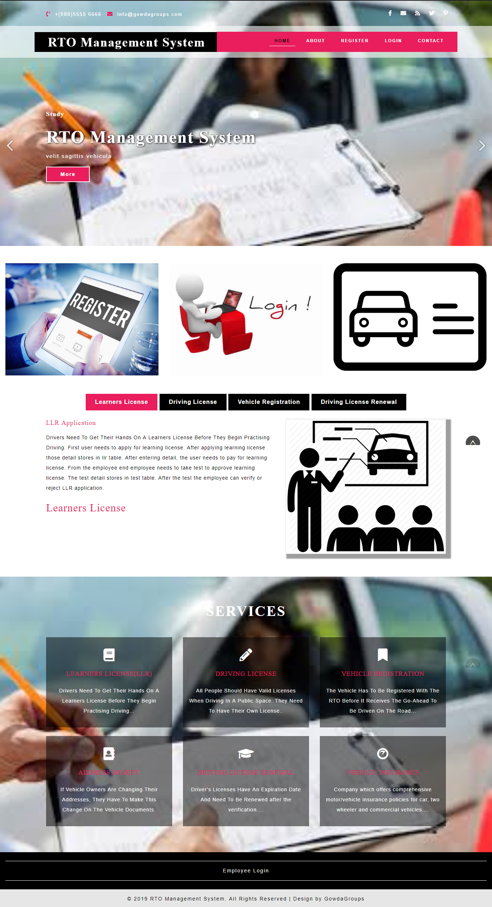

- Registration Form

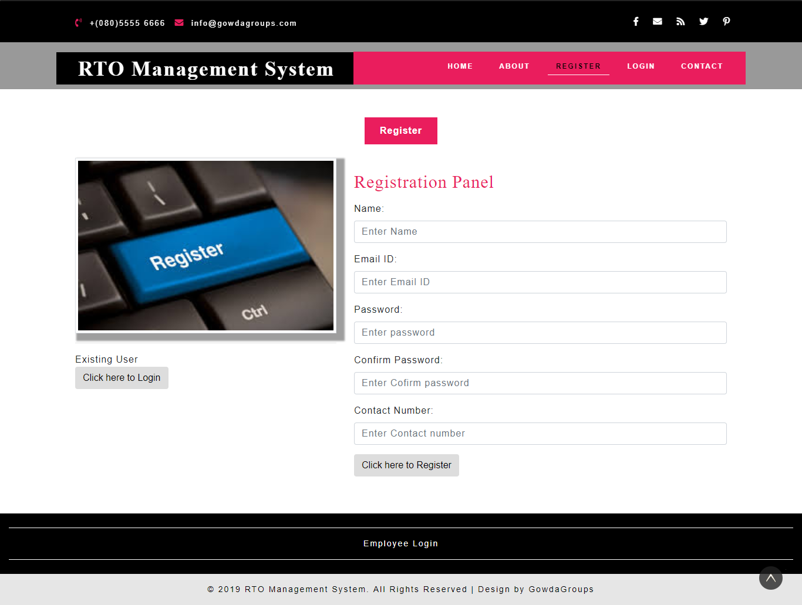

- Enroller Login Page

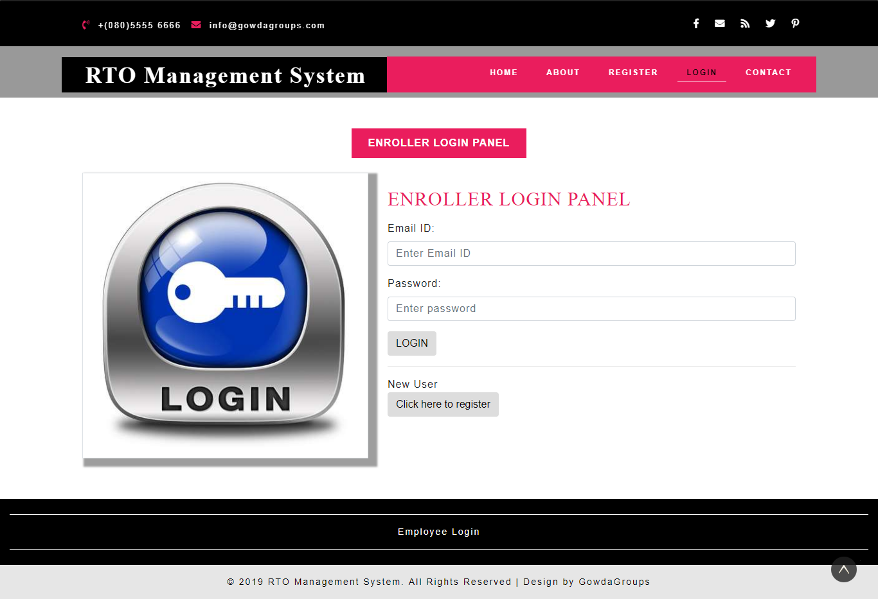
- LLR Form page:

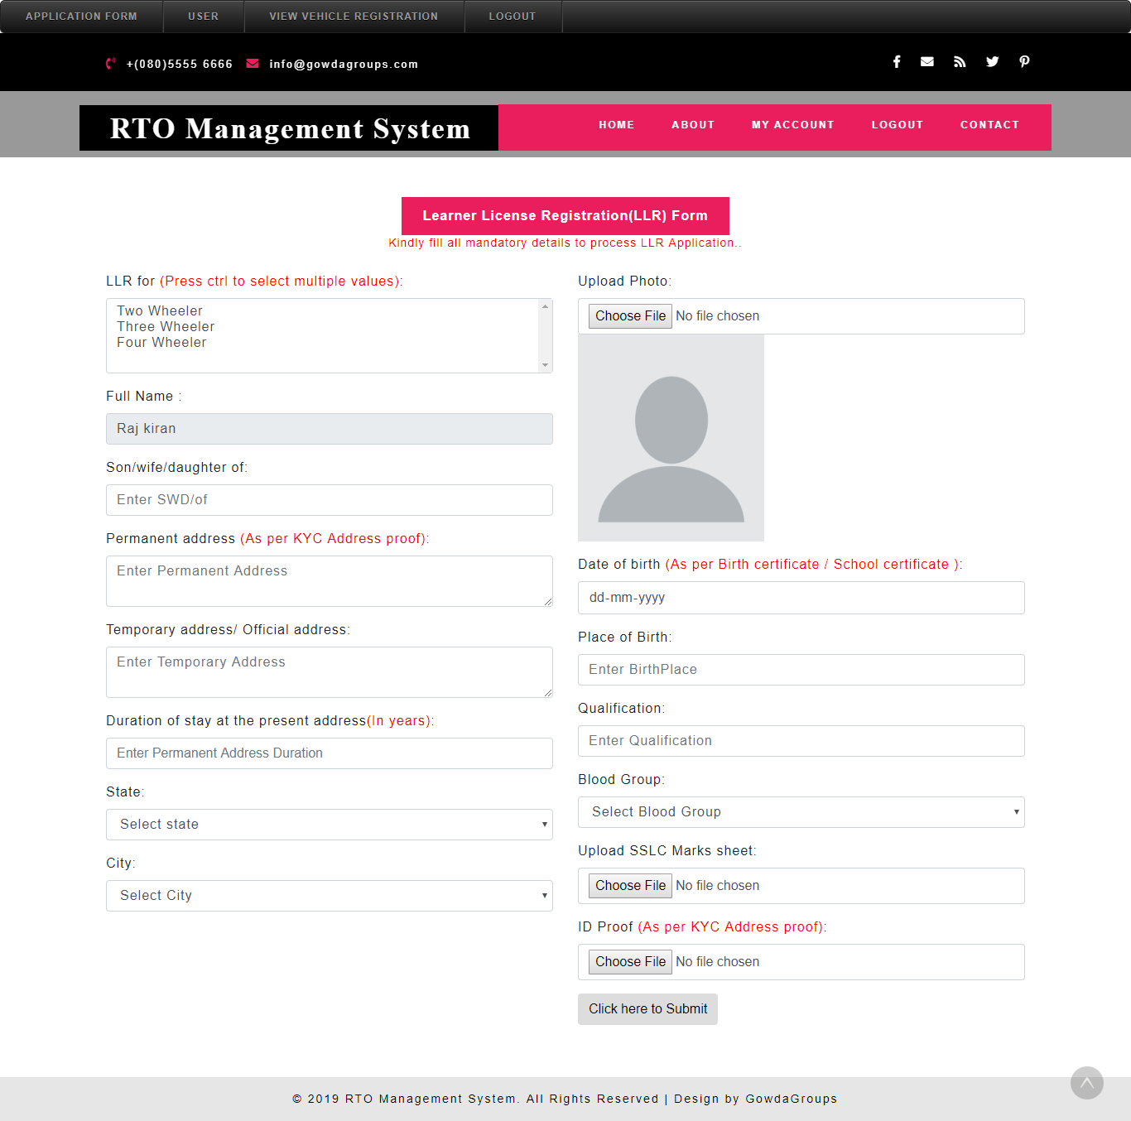

- Vehicle Registration Form page

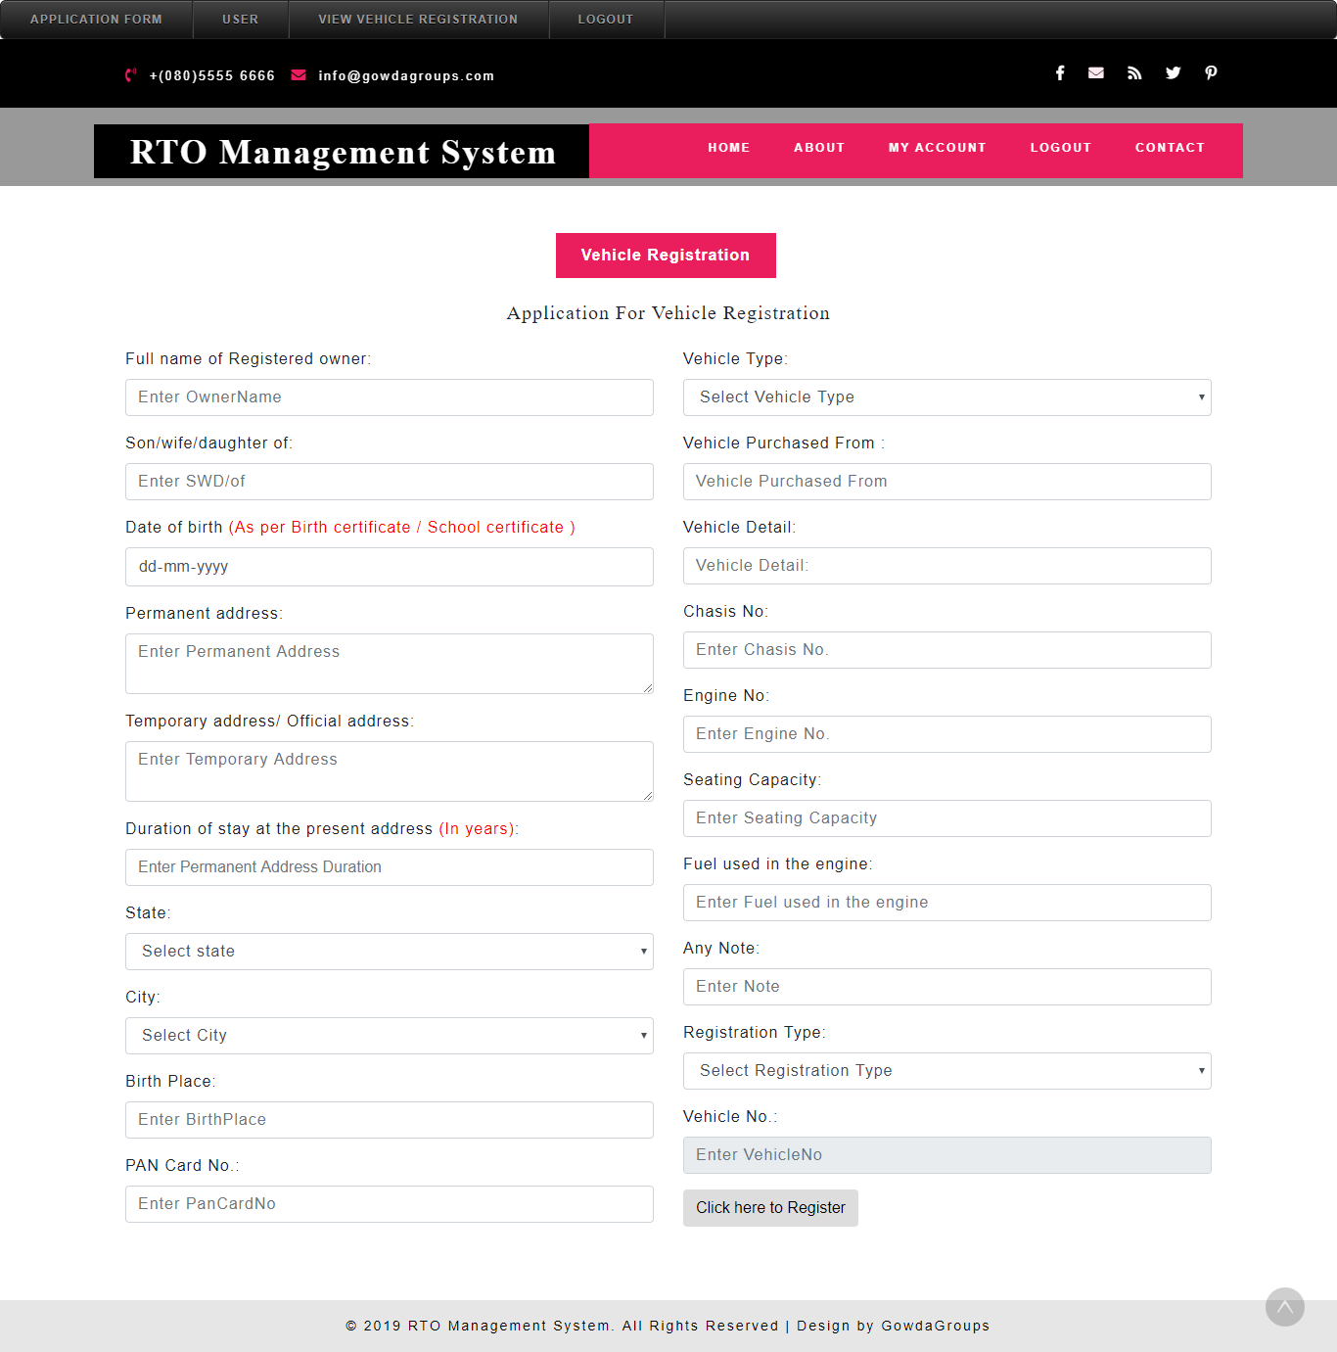

- Vehicle Insurance page

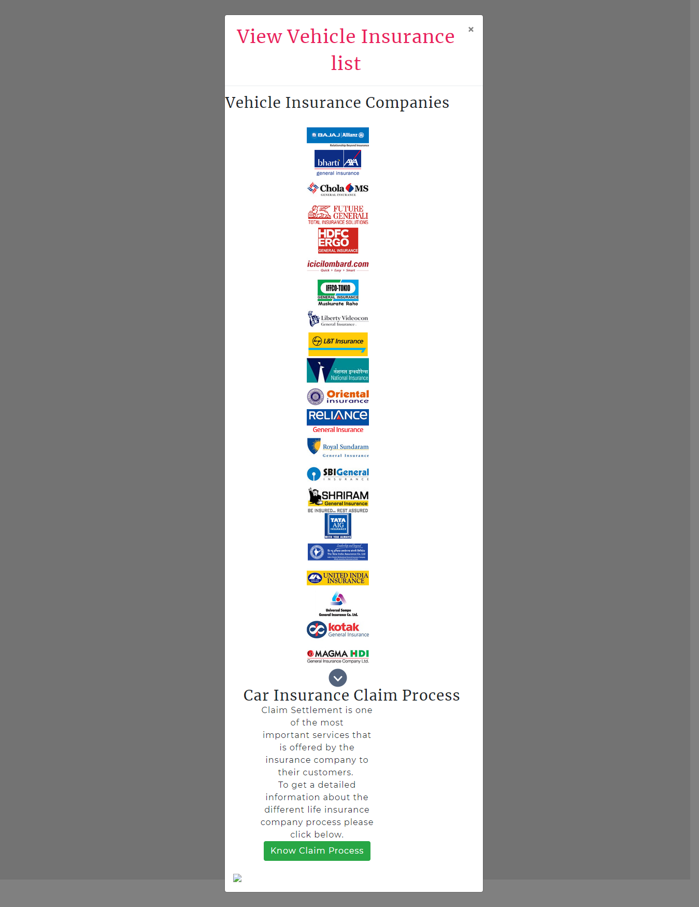

- Employee panel:

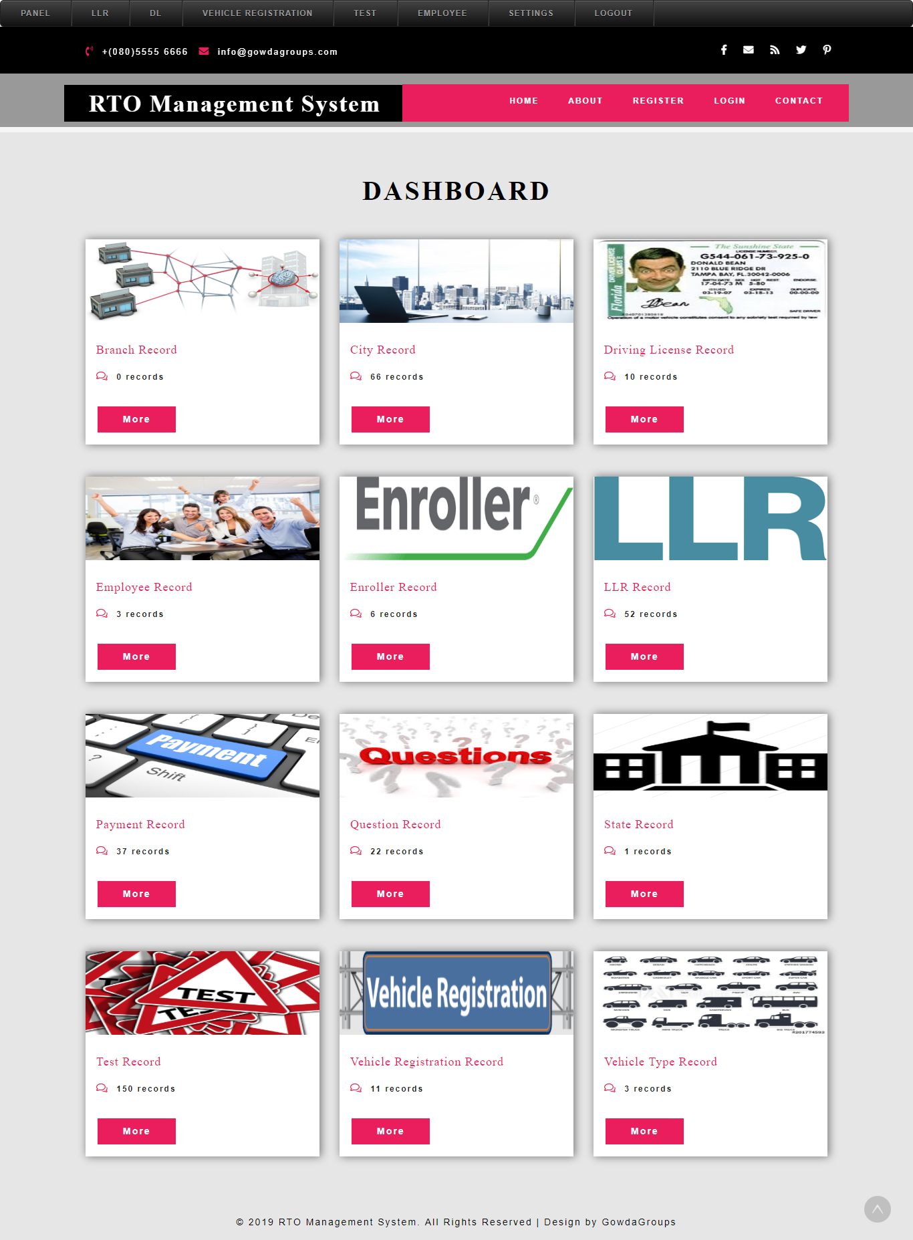

- Application Status:

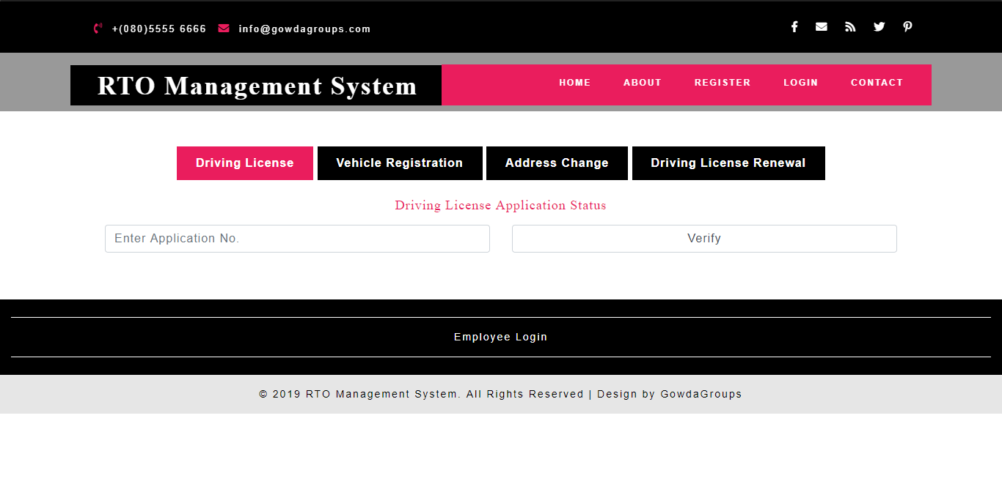
- User Panel:

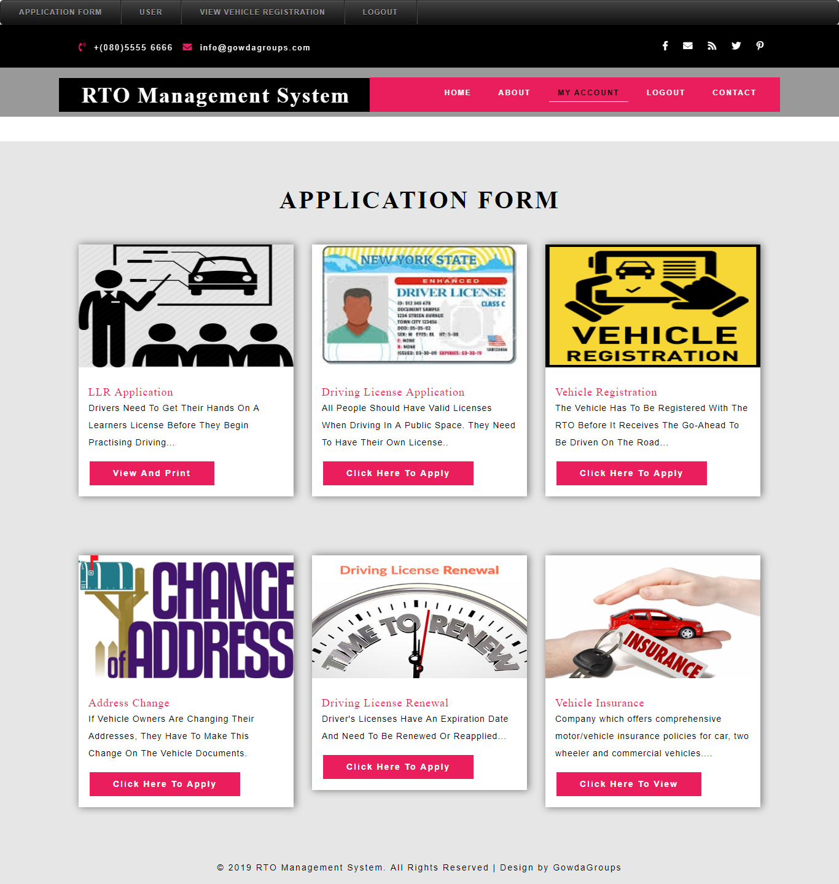
- User Change Password:

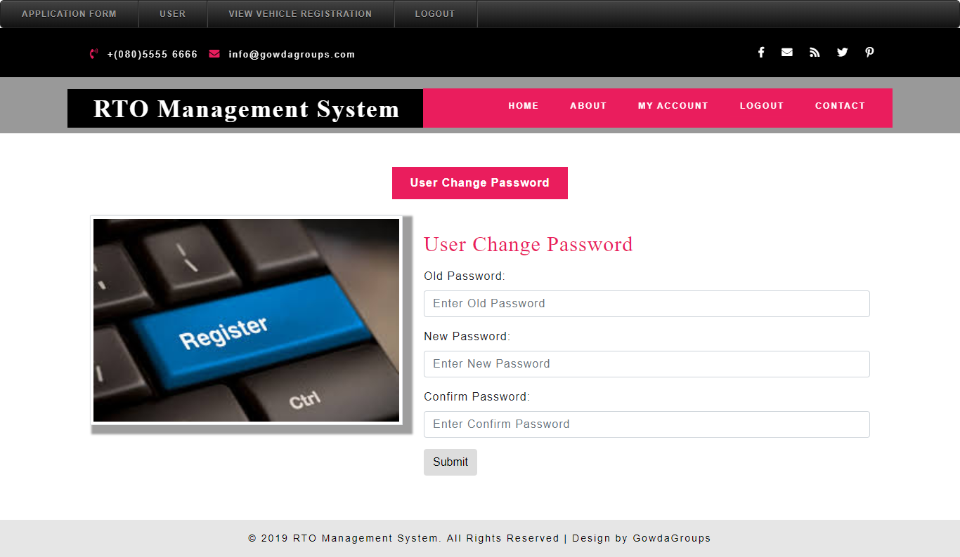
- Employee Add and View Branch:

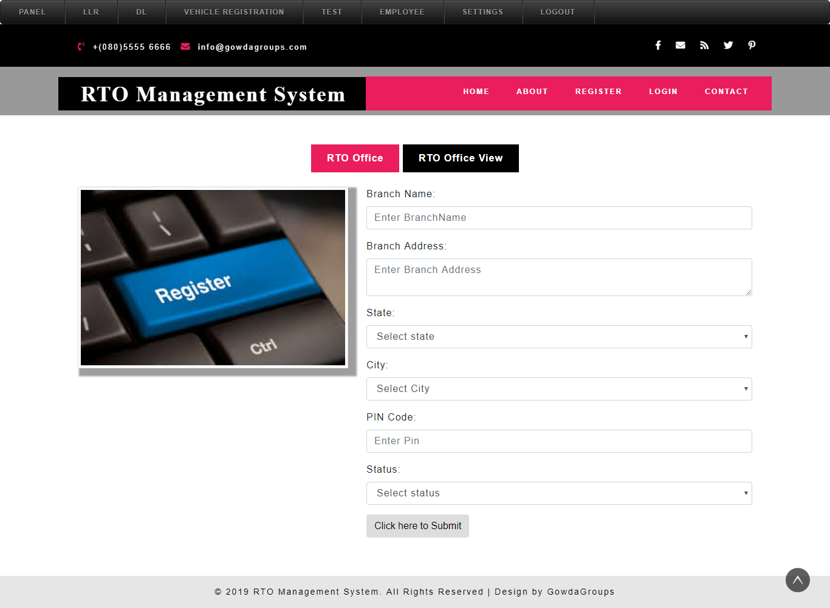

CHAPTER-9
USER MANUAL

9.USER MANUAL

Our RTO management System (RTOSYS) is a web-based application which is developed using PHP as front end and MSSQL as the back end. In order to run this the minimum software requirement are:
- Microsoft windows 7 and above.
- PHP and above.
- Web browser: internet explorer9 or higher, opera, chrome.
The main objective of RTOSYS is to provide various services of RTO and to digitize the process. Keeping our objective in mind, we have developed this software
9.1. Execution method
- For administrator:
  - Administrator should provide his user name and password in order to login to system. The administrator can select the following options.
- Staff registration
    - Here the administrator will be able to create a login to the newly recruited RTO staff by proving their details.
- Manage users
    - Here the administrator will be able to delete the account created by the users and also remove the retired RTO staff.
- Upload notice
    - Here the administrator will be able to upload the notices.
- Add RTO
    - Here the admin will be allowed to add newly established RTO according to their district.
- Payments
    - Here the admin is able to view all the payments done by the users.
- Complaints
    - Here the admin is able to view all the complaints filled by users

9.2. For RTO Staff
RTO staff should provide his user name and password in order to login to system. He can perform the following activities.
- Verification
  - Here the RTO staff is able to verify the information provided by the users in their applications and approve or reject the application.
- Profile
  - Here RTO staff will be able to view his profile and change his password.

9.3. For new user
New users need to be registered in the RTOSYS in order the use the system. User needs to provide few details to the system in order to complete the registration

9.4. For registered user
Registered user should give his user name and password to login to the system. He can perform the following activities. Here RTO staff will be able to view his profile and change his password
• learner License
• Driving License
• Vehicle Registration
• Address modification
• Driving License renewal

9.5. Installation guidelines
To run the software the user as to check whether the system satisfies the following requirements.
• Microsoft windows7 or above.
• Hyper Text Transfer Protocol (HTTP)
•PHP or above
• Browsers like Internet Explorer9 or above, Opera, Chrome.

9.6. Our RTO management System covers the following Features
• Database security is maintained.
• Easy to access from anywhere anytime.
• User-friendly interface.

CHAPTER-10
Conclusion

10.Conclusion

We here by conclude this project called RTO Management System in order to issue the Driving License, Learner`s License, Vehicle Registration can be done online to avoid the purpose of cause from traffic police, During the vehicle must have separate documents when anyone who wants to drive, they must follow the rule of Karnataka Government. This project works online which helps RTO office employees and Indian citizens. The System keeps track of the transactions in the RTO office.

CHAPTER-11
Bibliography

11.Bibliography

Books:
    - Software engineering by Pankaj Jalote.
    - Learning PHP, MySQL, JavaScript and CSS: A Step-by-Step Guide to Creating Dynamic Websites by Robin Nixon.
Website:
    - www.w3schools.com
    - www.tutorialspoint.com

CHAPTER-12
Future Enhancement

12. Future Enhancement

- In future this project can be update in many ways where the user easy purpose it can be modified to the various fields in the project. This web application helps for RTO office employees as well as citizens of India. It will reduce considerably the difficulties faced on existing system, with minimum error and difficulties.

